Date: 12-10-21
WEBLEM 5
Introduction to Domain Databases

1. Prosite: PROSITE is a method of determining what is the function of uncharacterized proteins translated from genomic or cDNA sequences. It consists of a database of biologically significant sites and patterns formulated in such a way that with appropriate computational tools it can rapidly and reliably identify which known family of protein (if any) the new sequence belongs to.
The PROSITE database uses two kinds of signatures or descriptors to identify conserved regions, i.e. patterns and generalized profiles, which both have their own strengths 30 and weaknesses defining their area of optimum application.
PROSITE is complemented by ProRule , a collection of rules based on profiles and patterns, which increases the discriminatory power of profiles and patterns by providing additional information about functionally and/or structurally critical amino acids. The ProRule section of PROSITE is constituted of manually created rules that can automatically generate annotation in the UniProtKB/Swiss-Prot format based on PROSITE motifs.
2. Pfam: Pfam is a database of protein domain families. Pfam contains curated multiple sequence alignments for each family, as well as profile hidden Markov models (profile HMMs) for finding these domains in new sequences. Pfam contains functional annotation, literature references and database links for each family. There are two multiple alignments for each Pfam family, the seed alignment that contains a relatively small number of representative members of the family and the full alignment that contains all members in the database that can be detected. All alignments use sequences taken from pfamseq, which is a non-redundant protein set composed of SWISS-PROT and SP-TrEMBL. The profile HMM is built from the seed alignment using the HMMER package, which is then used to search the pfamseq sequence database.
3. InterPro: InterPro is an integrative database which was founded 10 years ago when the PROSITE, PRINTS, Pfam and ProDom databases formed a consortium to amalgamate the predictive signatures they individually produced into a single resource. Since then, six other member databases have also joined and their data has been integrated: SMART, TIGRFAMs, PIRSF, SUPERFAMILY PANTHERand Gene3D.
4. PRINTS: The last two decades have seen remarkable advances in molecular biology: 20 years ago sequencing a single gene was considered a monumental technical achievement; today, the sequencing of whole genomes has become almost routine. Advances in the fundamental techniques of sequencing, in concert with advances in laboratory automation and robotics, have led to the rapid and unprecedented accumulation of macromolecular sequence data. The challenge resides not just in the management of this huge quantity of information, but also in its analysis. One of the main goals of bioinformatics is to uncover the knowledge implicit within the data.
The decisive step in this knowledge-discovery process is often the identification of the family to which a newly-identified gene belongs; from this devolves a wealth of insights into function. With its links to 3D structure and post-translational modifications, and thus biological function, it is generally thought that the amino acid sequence, rather than the nucleic acid sequence, is the most appropriate level at which to seek such relationships.
Reference:
- https://prosite.expasy.org/prosuser.html
- Bateman, A. (2000). The Pfam Protein Families Database. Nucleic Acids Research, 28(1), 263–266. https://doi.org/10.1093/nar/28.1.263
- Hulo, N. (2006a). The PROSITE database. Nucleic Acids Research, 34(90001), D227–D230. https://doi.org/10.1093/nar/gkj063
- Hulo, N. (2006b). The PROSITE database. Nucleic Acids Research, 34(90001), D227–D230. https://doi.org/10.1093/nar/gkj063
- Hunter, S., Apweiler, R., Attwood, T. K., Bairoch, A., Bateman, A., Binns, D., Bork, P., Das, U., Daugherty, L., Duquenne, L., Finn, R. D., Gough, J., Haft, D., Hulo, N., Kahn, D., Kelly, E., Laugraud, A., Letunic, I., Lonsdale, D., . . . Yeats, C. (2009). InterPro: the integrative protein signature database. Nucleic Acids Research, 37(Database), D211–D215. https://doi.org/10.1093/nar/gkn785

Date: 12-10-21
WEBLEM 5a
Prosite
(URL: https://prosite.expasy.org)
Aim:
To study Prothrombin domain information using Prosite database.
Introduction:
PROSITE is a method of determining what is the function of uncharacterized proteins translated from genomic or cDNA sequences. It consists of a database of biologically significant sites and patterns formulated in such a way that with appropriate computational tools it can rapidly and reliably identify which known family of protein (if any) the new sequence belongs to.
The PROSITE database uses two kinds of signatures or descriptors to identify conserved regions, i.e. patterns and generalized profiles, which both have their own strengths 30 and weaknesses defining their area of optimum application.
Cadherins (named for "calcium-dependent adhesion") are a type of cell adhesion molecule(CAM) that are important in the formation of adherens junctions to allow cells to adhere to each other .Cadherins are a class of type-1 transmembrane proteins, and they are dependent on calcium (Ca2+) ions to function, hence their name. Cell-cell adhesion is mediated by extracellular cadherin domains, whereas the Intracellular cytoplasmic tail associates with numerous adaptors and signaling proteins, collectively referred as the cadherin adhesome.

Methodology:
- Open homepage for Prosite database.
- Search for query “Prothrombin” using quick scan more of Prosite with help of FASTA sequence.
- Observe the result for hits by profile and hits by pattern.
- Interpret the results.
Observation:
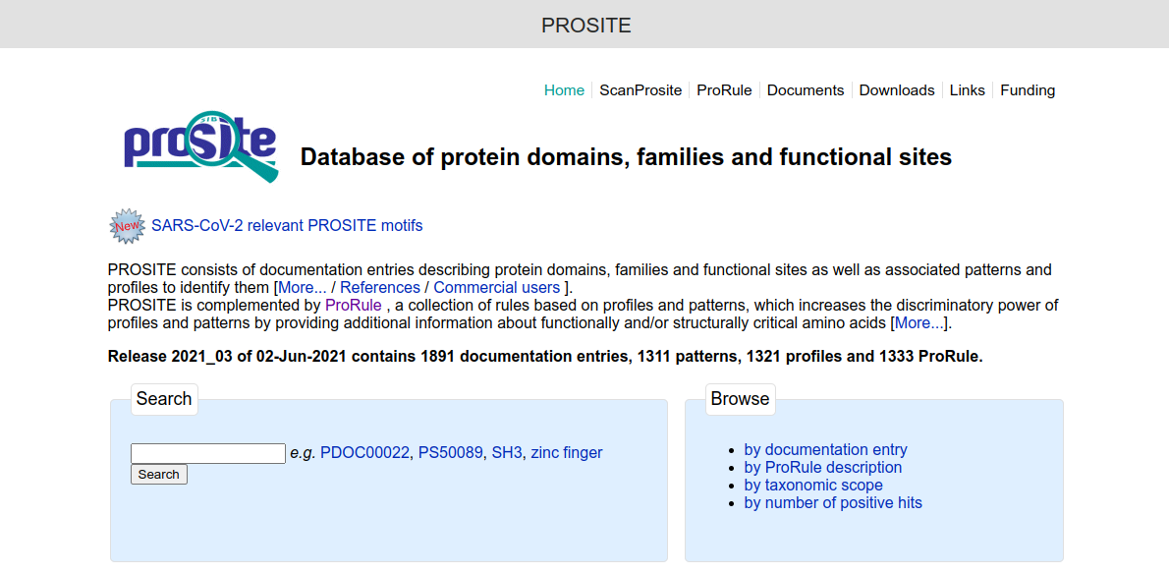
Fig1. Homepage of Prosite Database
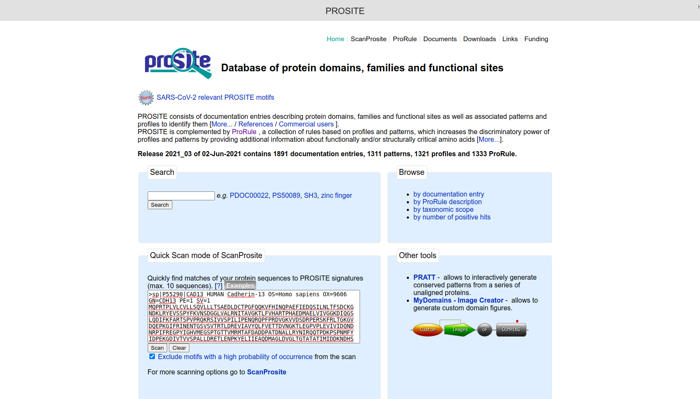
Fig2. Search page for query “Cadherin” using quick scan mode of ScanProsite in Prosite database.
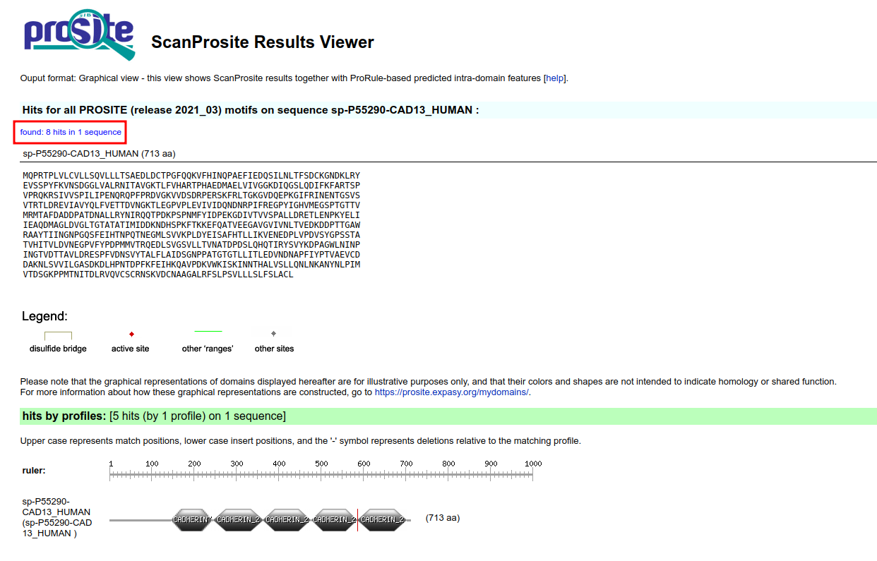
Fig3. Result page for query “Cadherin” in Prosite database.
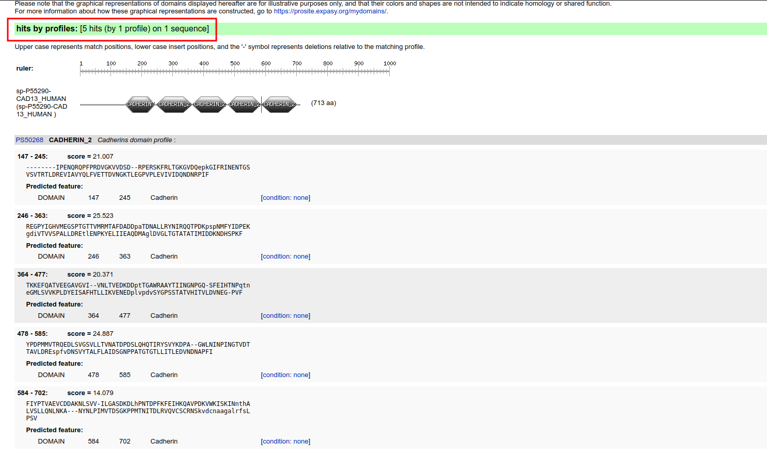
Fig4. Result page for query “Cadherin” in Prosite database showing hits by profiles.
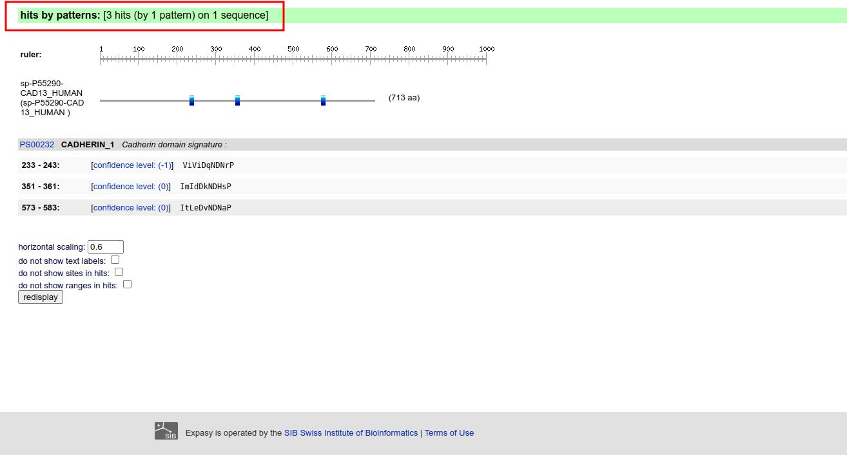
Fig5. Result page for query “Cadherin” in Prosite showing hits by profiles.

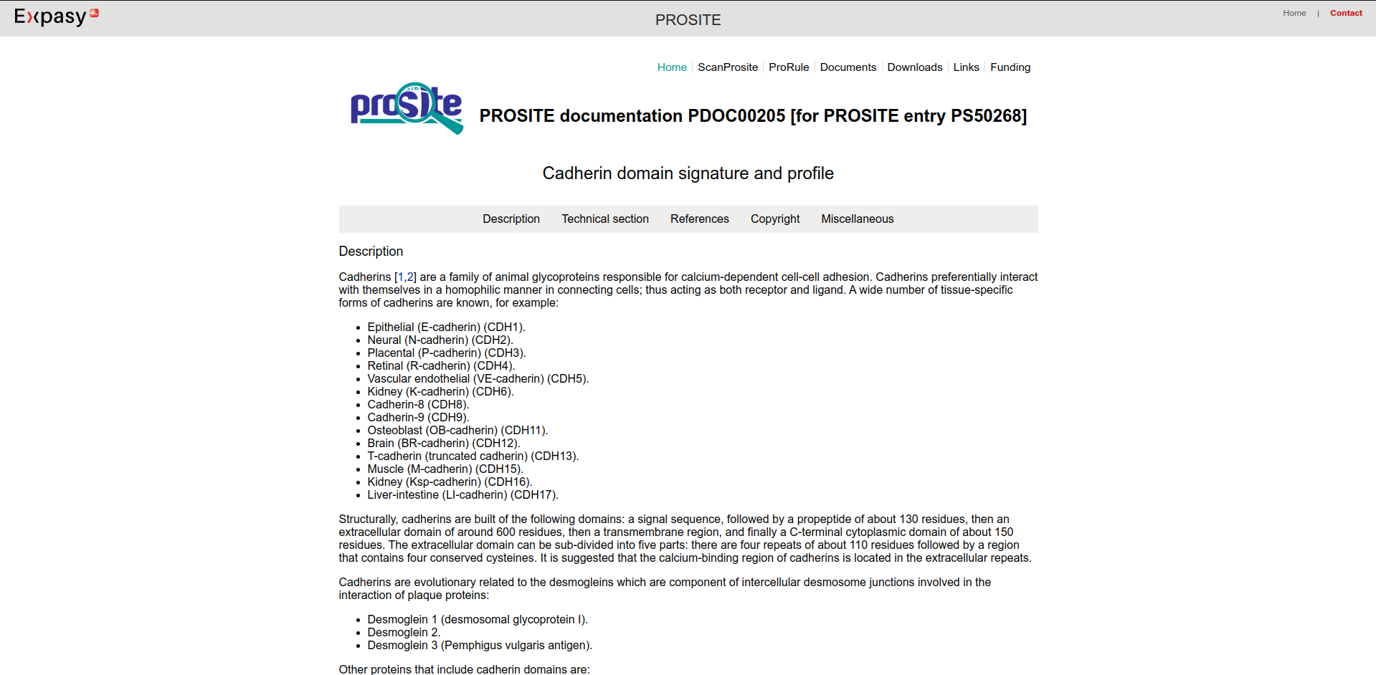
Fig6. Result page for “Cadherin Domain signature” and profile
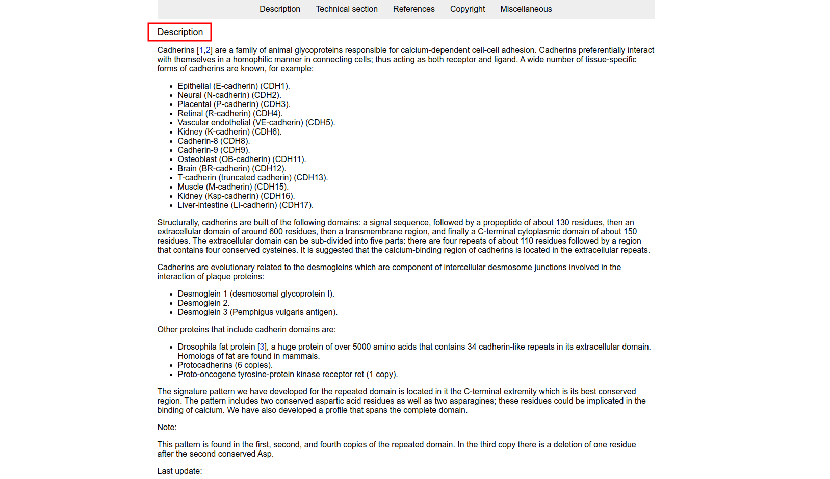
Fig7. Description page for “Cadherin Domain signature”
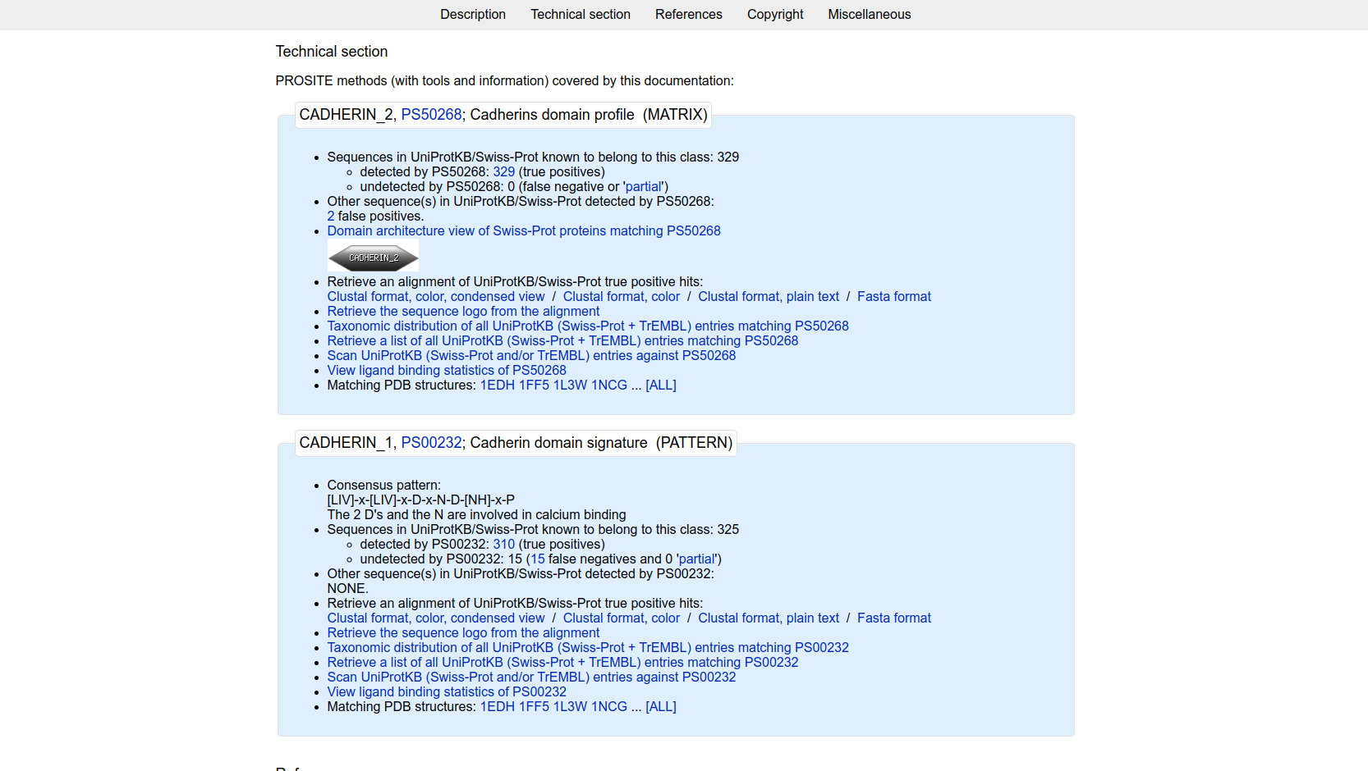
Fig8. Result page showing Technical section for “Cadherin_2:PS50268”
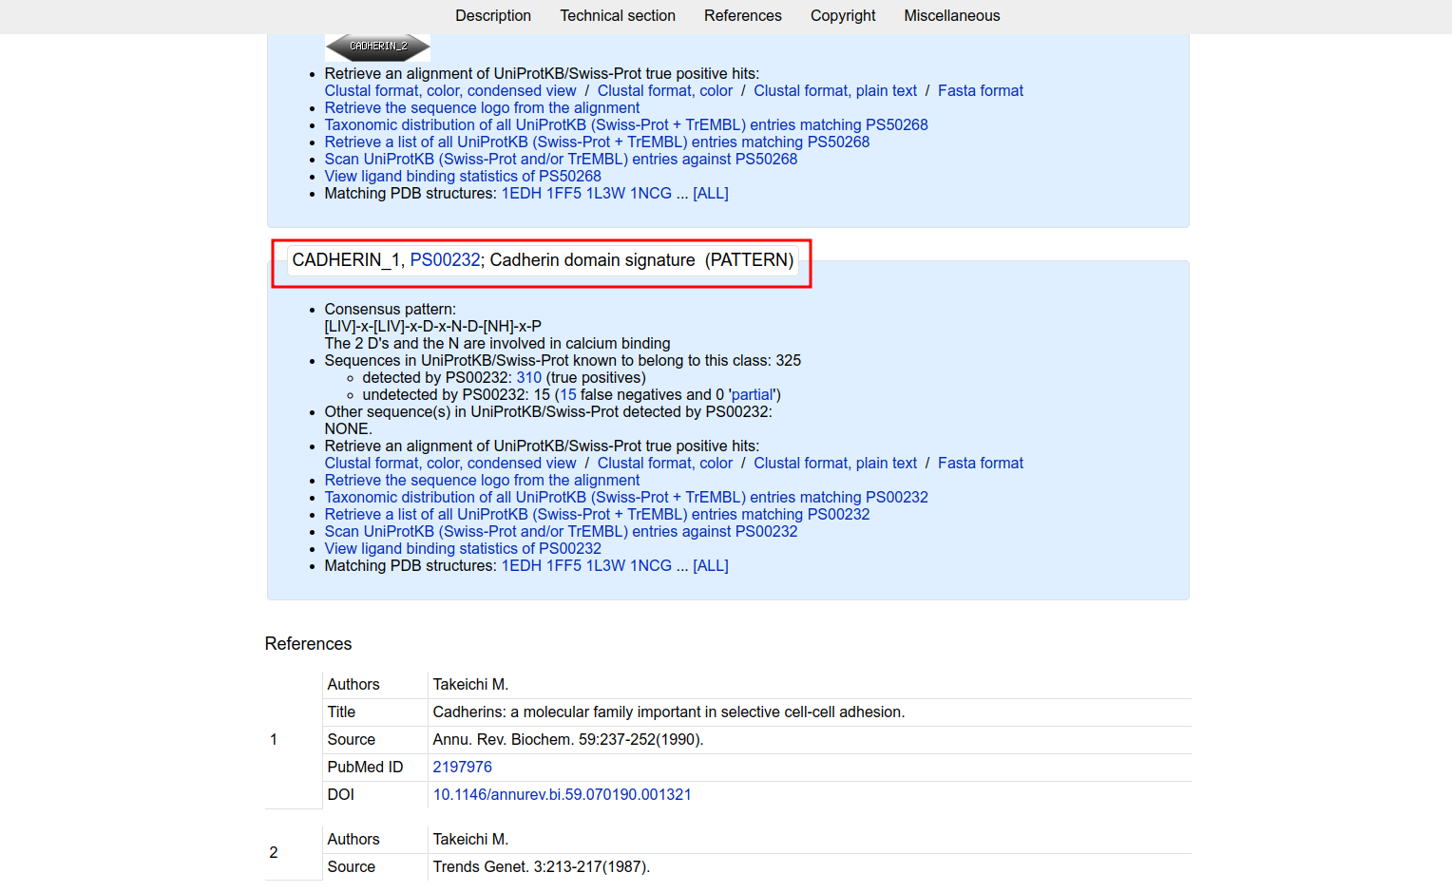
Fig9. Result page for “Cadherin” which shows consensus patthern for Cadherin Domain signature

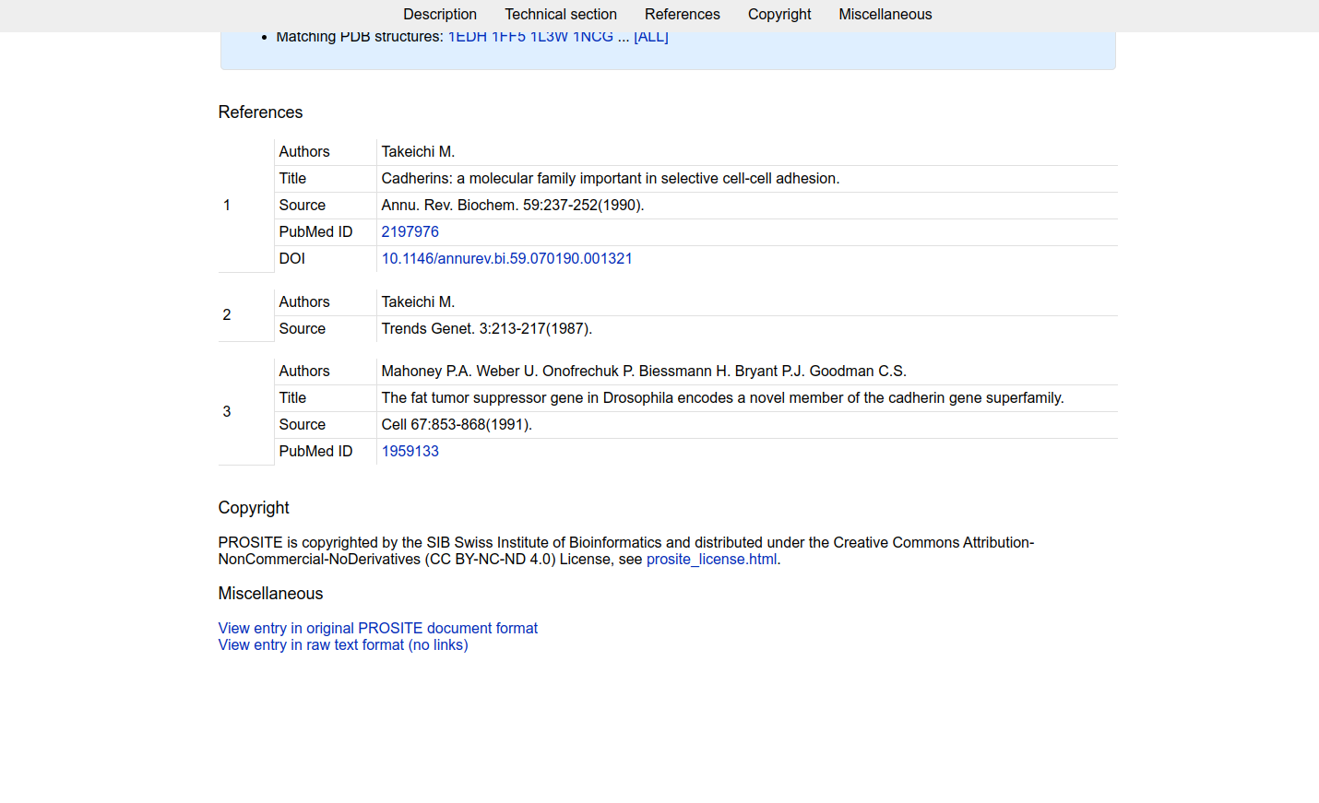
Fig10. Result page for “Cadherin” showing references
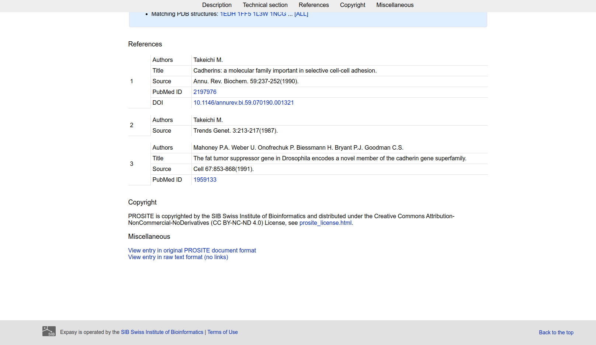
Fig11. Result page for Cadherin domain showing Copyright and miscellaneous

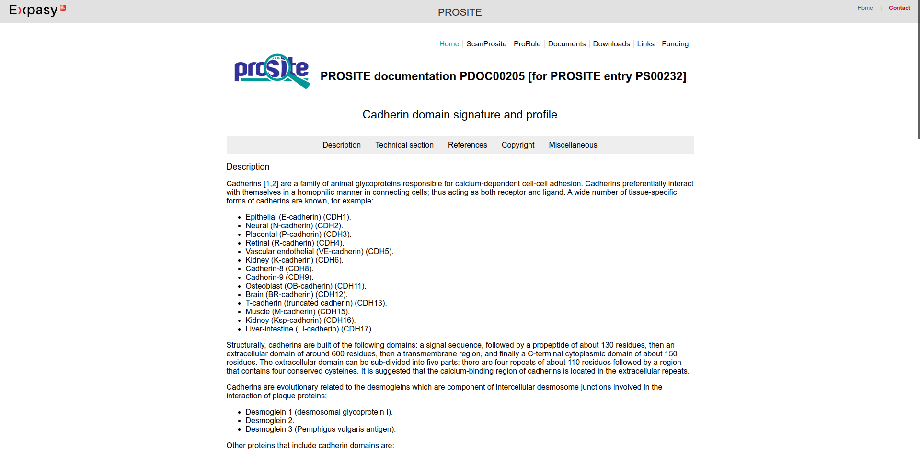
Fig12.Result page for Cadherin domain signature and profile
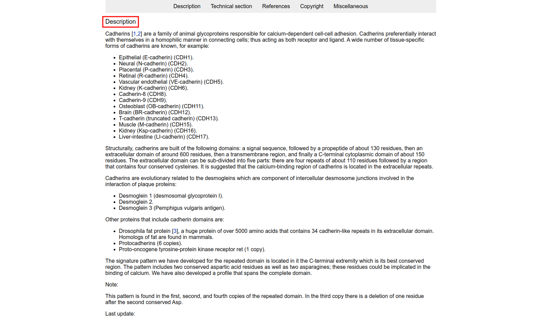
Fig13. Result page for Cadherin domain signature and profile showing Description
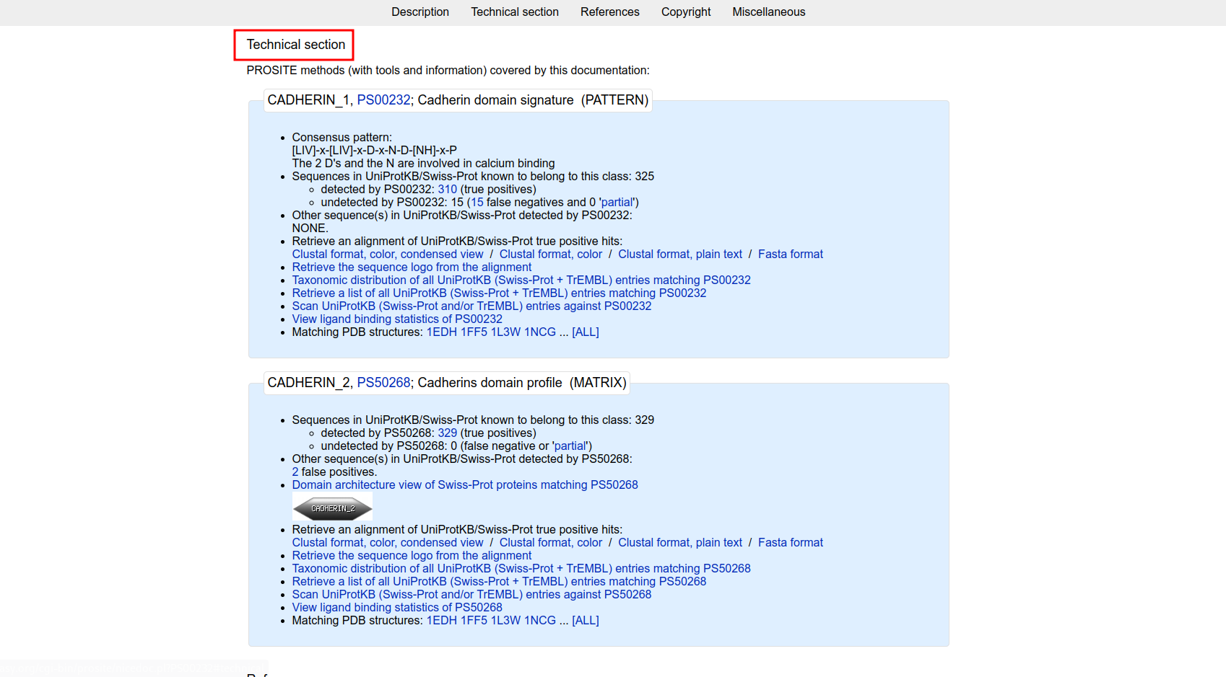
Fig14. Result page for Cadherin domain signature and profile showing Technical Section and consensus atther
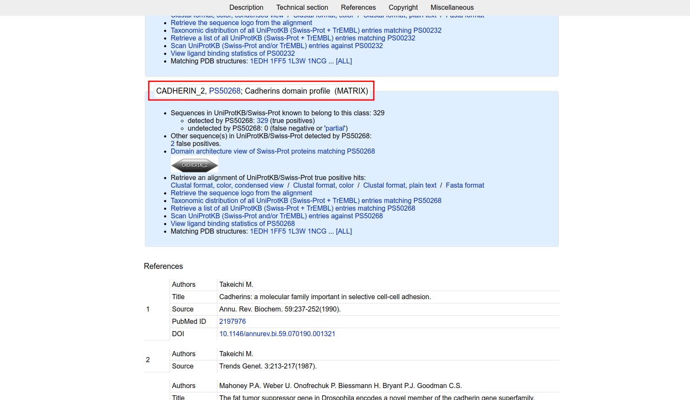
Fig15. Result page for Cadherin domain signature showing CADHERIN_2

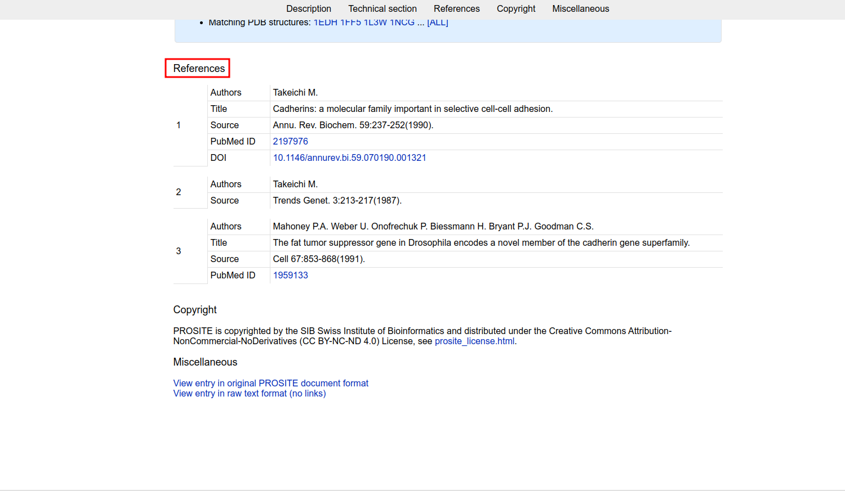
Fig16. Result page for Cadherin domain signature showing References
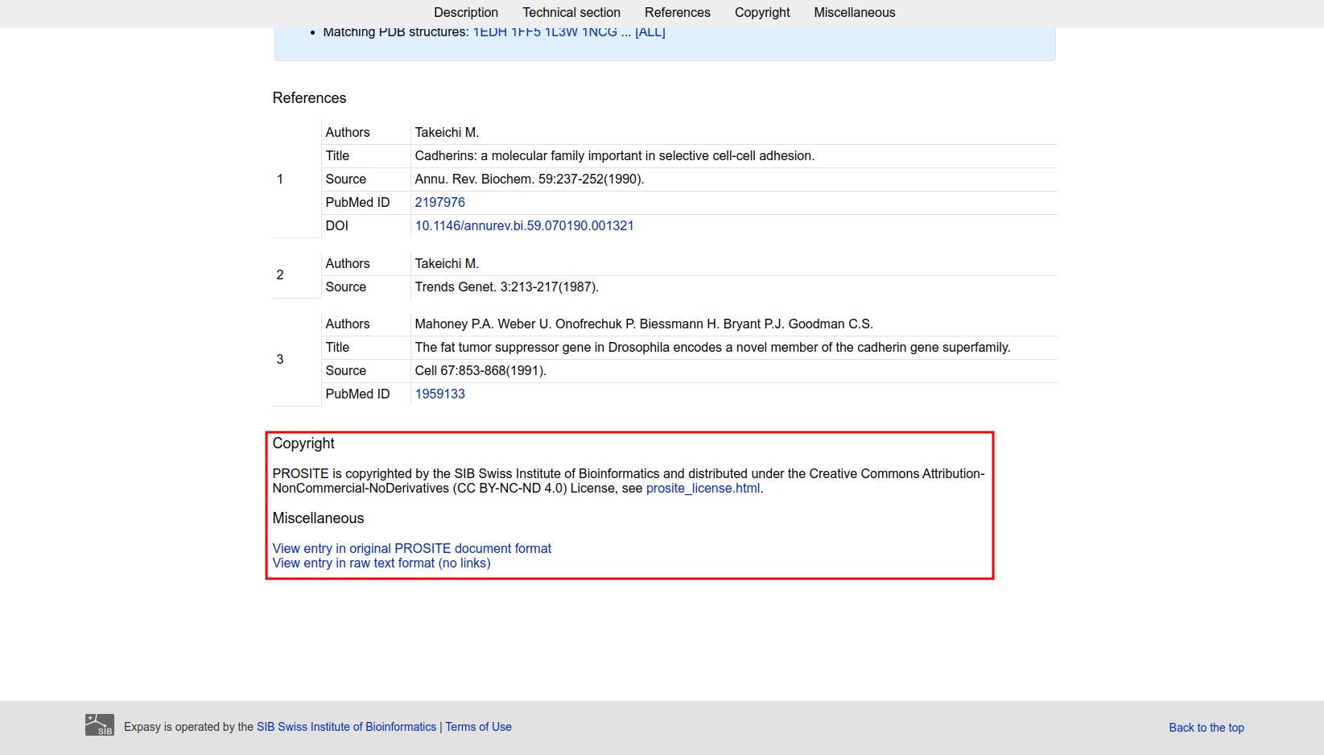
Fig17. Result page for Cadherin Domain signature showing Copyright and miscellaneous

Result:
The profile and patthern information for CADHERIN_1 and CADHERIN_2 was retrieved
Conclusion:
PROSITE database provides resources and tools for easy retrieval of profiles and patterns of various protein domains.
References:
- Maître, J. L., & Heisenberg, C. P. (2013). Three Functions of Cadherins in Cell Adhesion. Current Biology, 23(14), R626–R633. https://doi.org/10.1016/j.cub.2013.06.019
- (n.d.). Retrieved from https://www.uniprot.org/uniprot/P55290.fasta
- M., T., P.A., M., U., W., P., O., H., B., P.J., B., & C.S., G. (2004, May 01). Cadherin domain signature and profile. Retrieved from https://prosite.expasy.org/cgi-bin/prosite/nicedoc.pl?PS50268
- M., T., P.A., M., U., W., P., O., H., B., P.J., B., & C.S., G. (2004, May 01). Cadherin domain signature and profile. Retrieved from https://prosite.expasy.org/cgi-bin/prosite/nicedoc.pl?PS00232

Date: 12-10-21
WEBLEM 5b
Pfam
(URL: http://pfam.xfam.org/)
Aim:
To study Cadherin domain information using Pfam database.
Introduction:
Pfam is a database of protein domain families. Pfam contains curated multiple sequence alignments for each family, as well as profile hidden Markov models (profile HMMs) for finding these domains in new sequences. Pfam contains functional annotation, literature references and database links for each family. There are two multiple alignments for each Pfam family, the seed alignment that contains a relatively small number of representative members of the family and the full alignment that contains all members in the database that can be detected. All alignments use sequences taken from pfamseq, which is a non-redundant protein set composed of SWISS-PROT and SP-TrEMBL. The profile HMM is built from the seed alignment using the HMMER package, which is then used to search the pfamseq sequence database.
Cadherins (named for "calcium-dependent adhesion") are a type of cell adhesion molecule(CAM) that are important in the formation of adherens junctions to allow cells to adhere to each other .Cadherins are a class of type-1 transmembrane proteins, and they are dependent on calcium (Ca2+) ions to function, hence their name. Cell-cell adhesion is mediated by extracellular cadherin domains, whereas the Intracellular cytoplasmic tail associates with numerous adaptors and signaling proteins, collectively referred as the cadherin adhesome.
Methodology:
- Open homepage for Pfam database. (URL: http://pfam.xfam.org/)
- Search for query “Cadherin” using keyword search.
- Select a domain and observe the results.
- Interpet the results.
Observation:
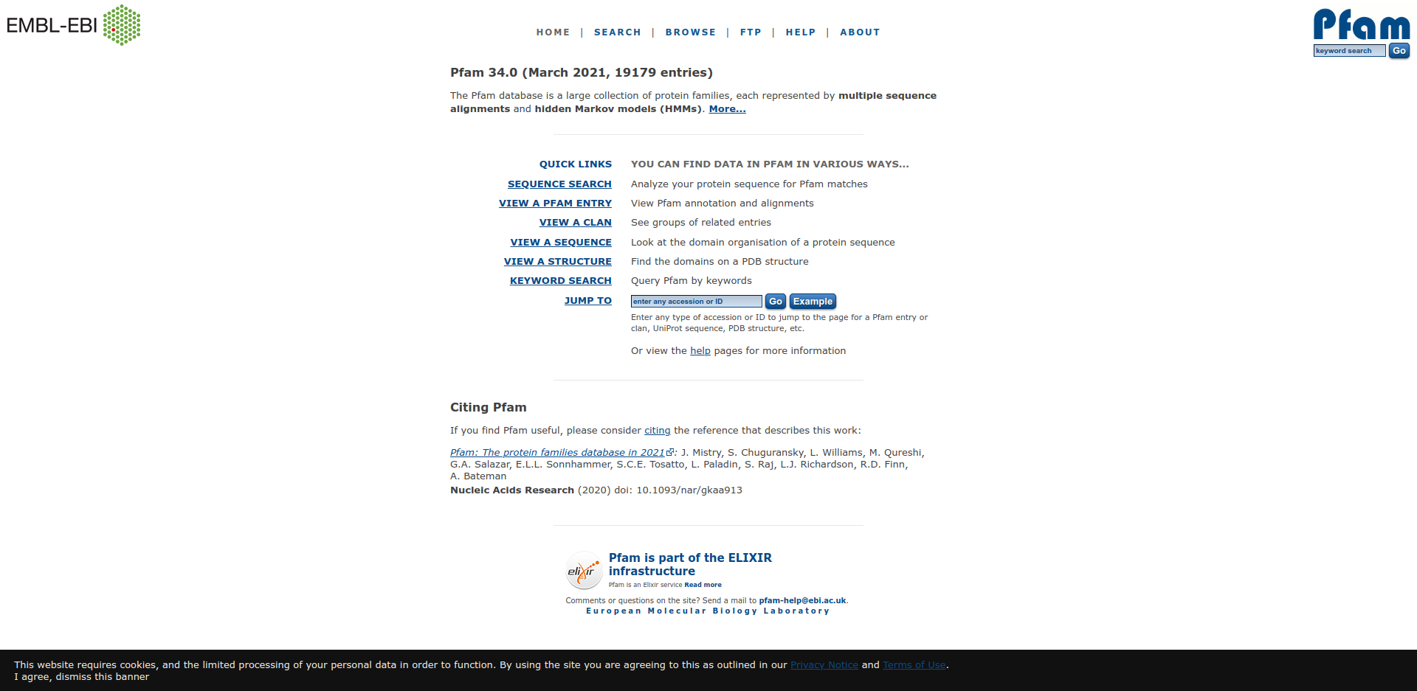
Fig1. Homepage of Pfam database
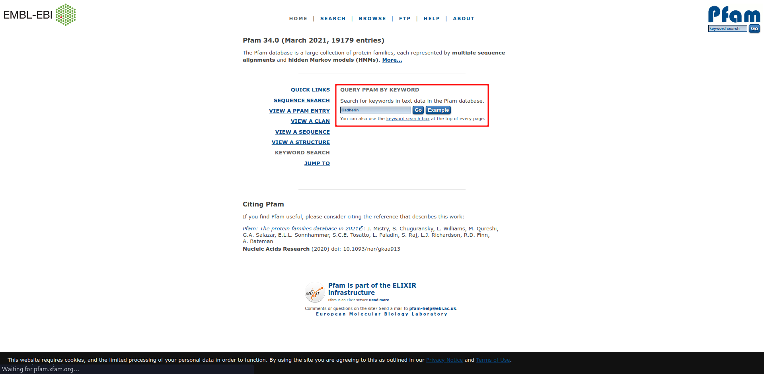
Fig2. Search page for query “Cadherin” Using Keyword search in Pfam database.

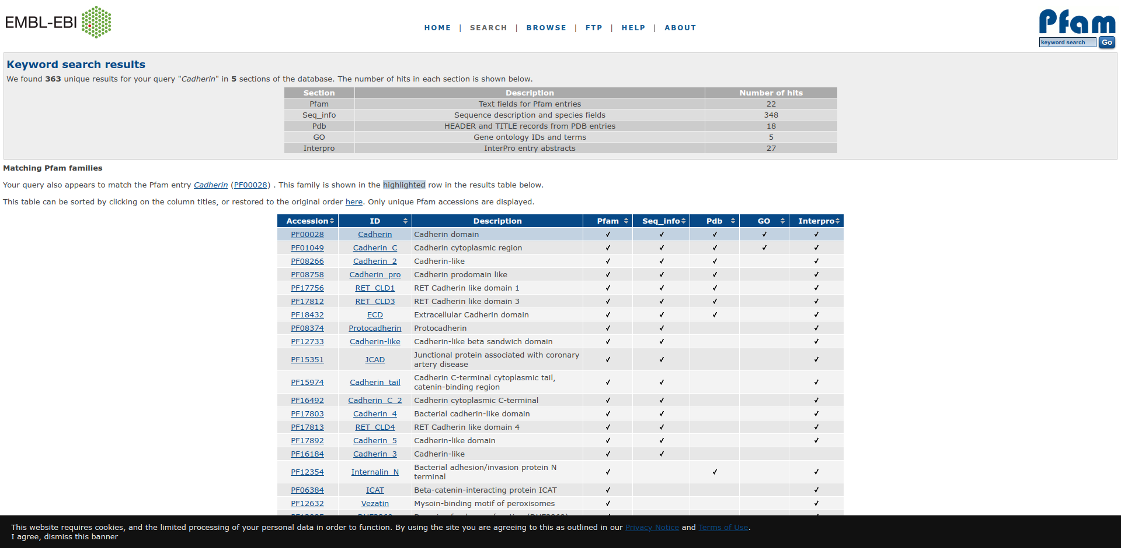
Fig3. Hit page for query “Cadherin” in Pfam database.

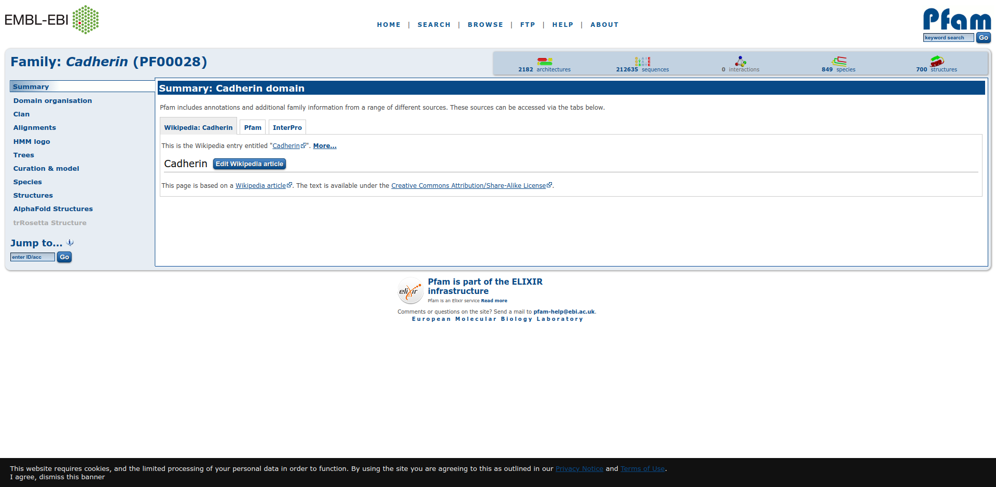
Fig4. Result page for Cadherin Domain showing summary

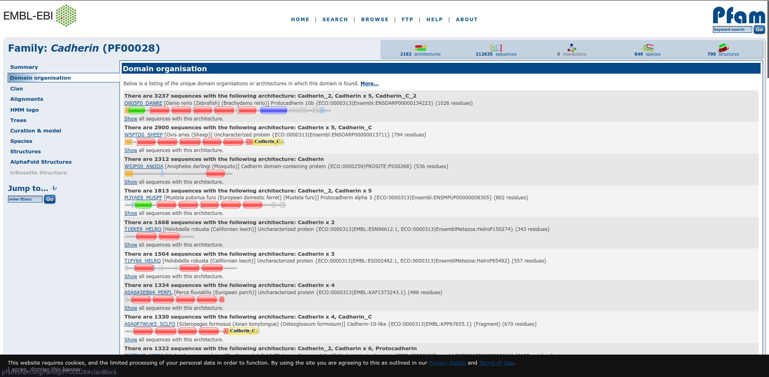
Fig5. Result page for Cadherin Domain showing domain organisation

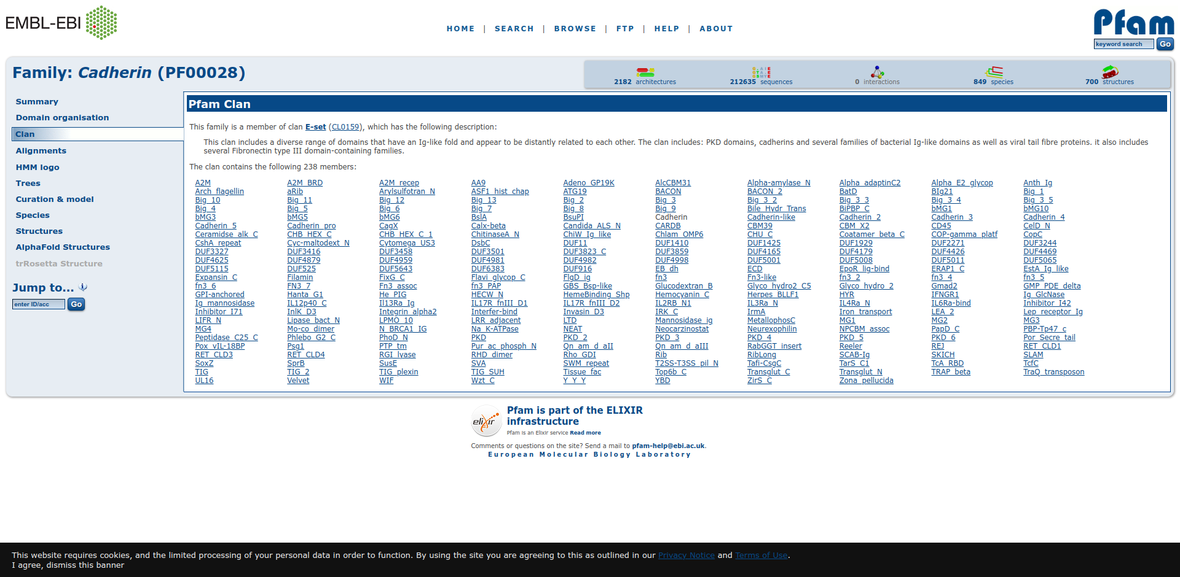
Fig6. Result page showing Cadherin Domain showing its clan

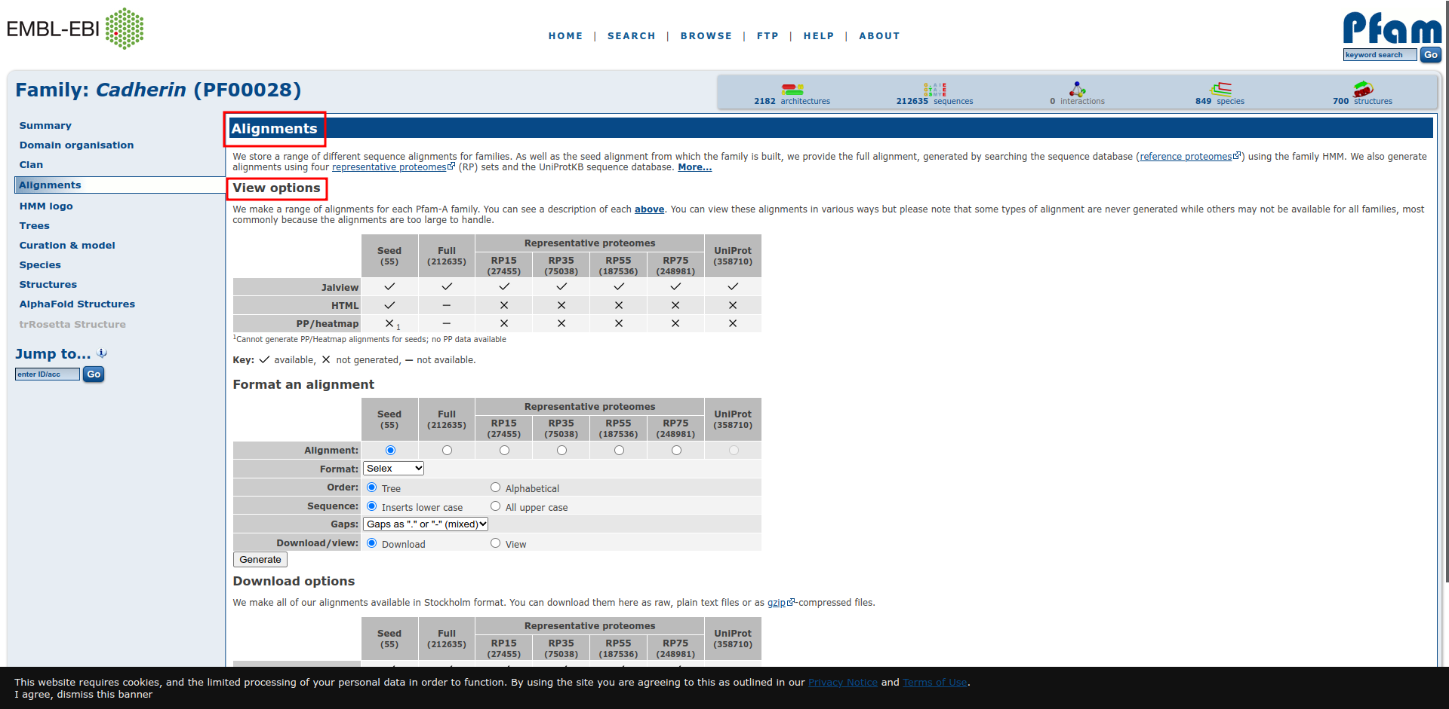
Fig7. Result page for Cadherin Domain Showing Alignments view options.

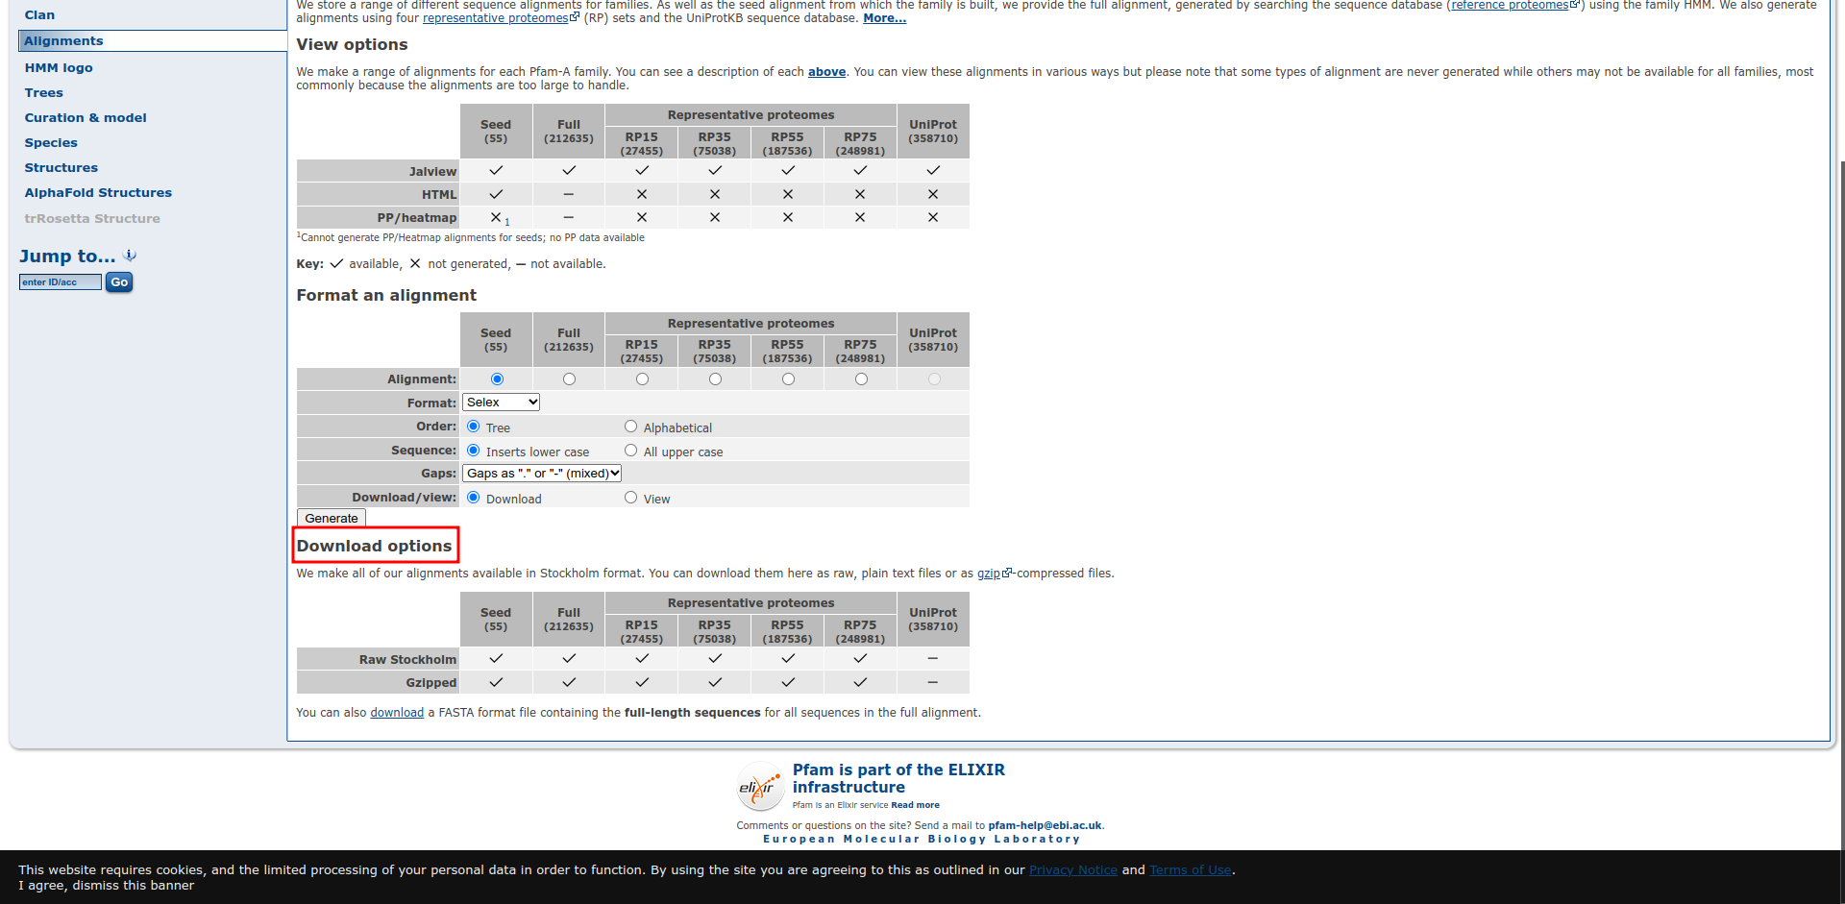
Fig8. Result page for Cadherin Domain showing download options for alignments.

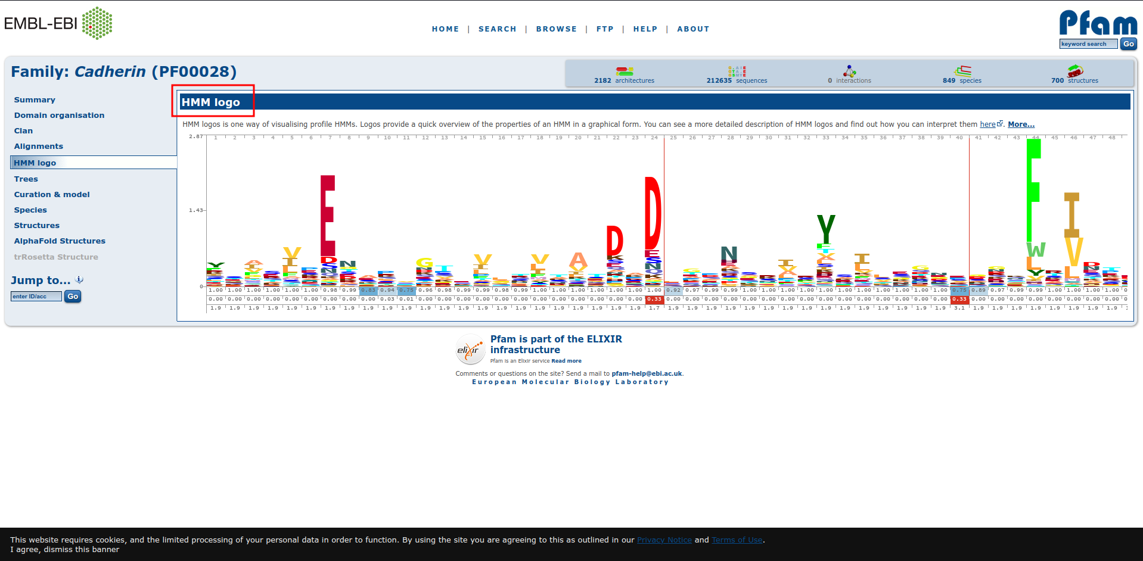
Fig9. Result page for Cadherin Domain showing HMM logo

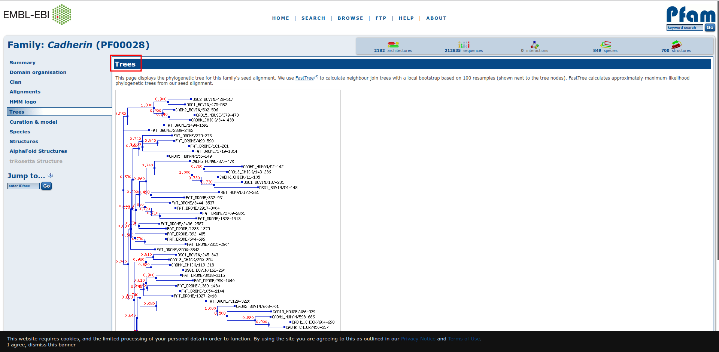
Fig10. Result page for Cadherin Domain showing Phylogenetic tree.

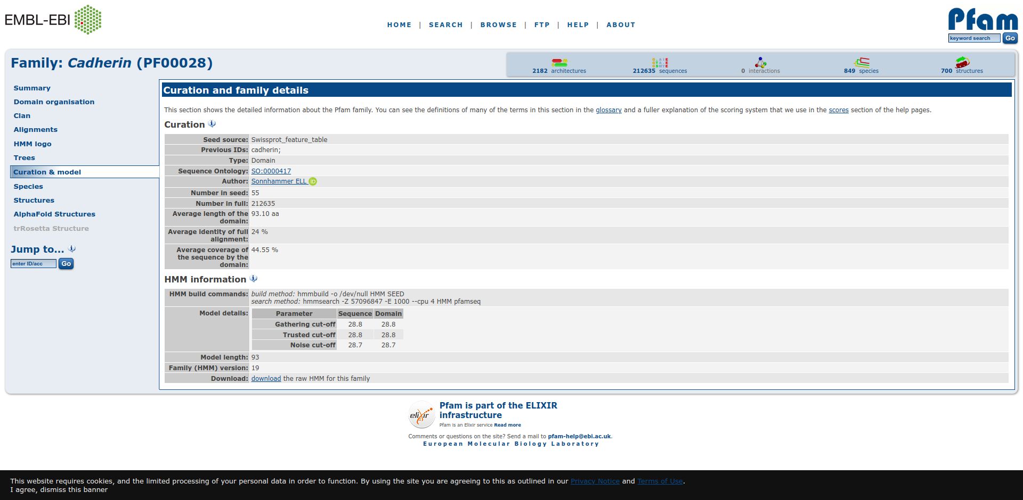
Fig11. Result page for Cadherin Domain showing curation and family details.
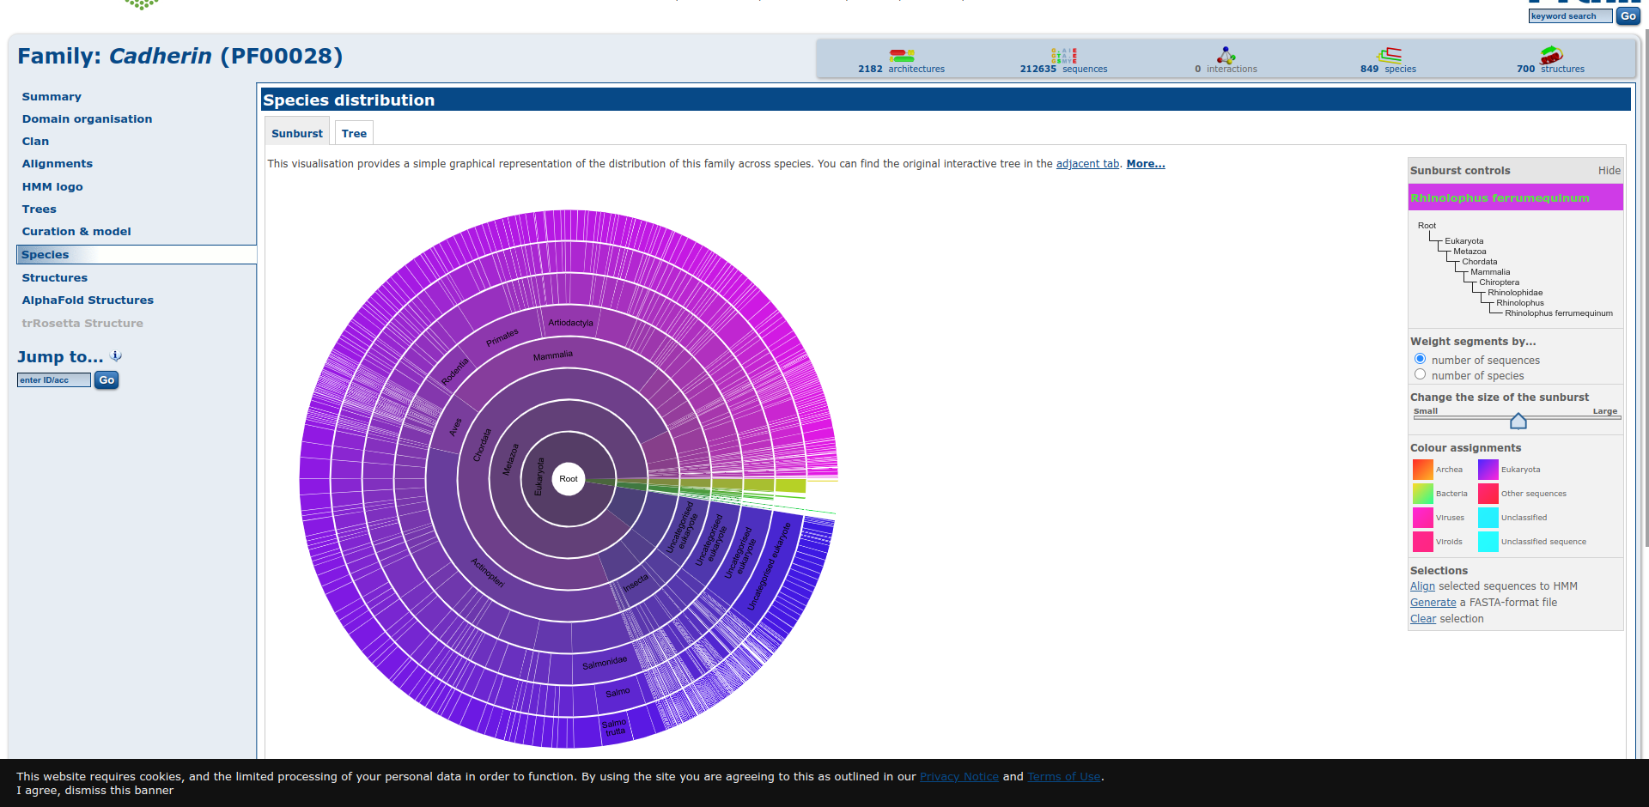
Fig12. Result page for Cadherin Domain showing species distribution in suburst format

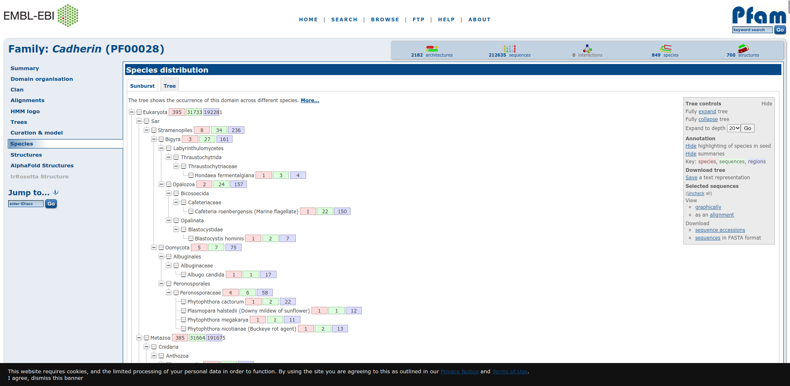
Fig13. Result page for Cadherin Domain showing species distribution in tree format
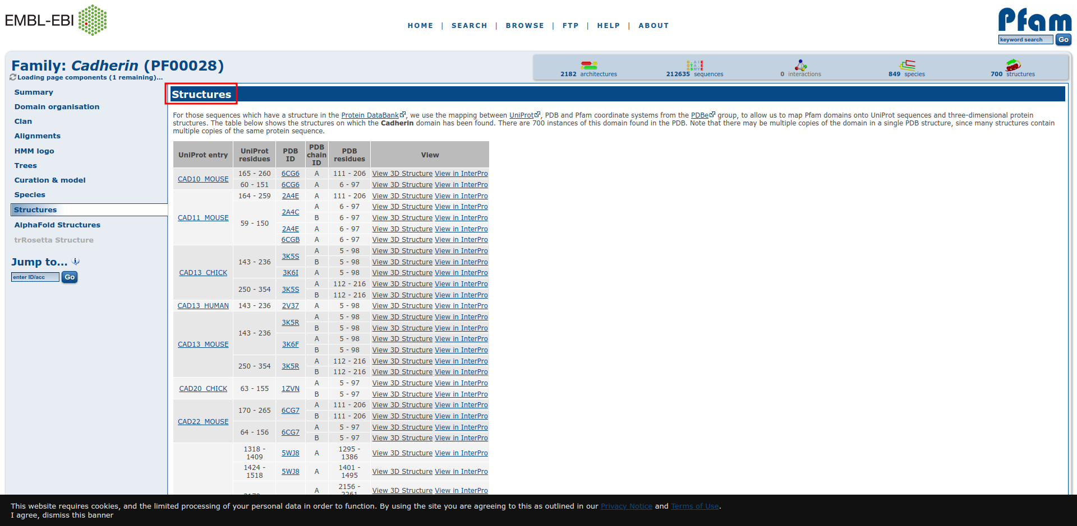
Fig14. Result page for Cadherin Domain showing structures of various chains.

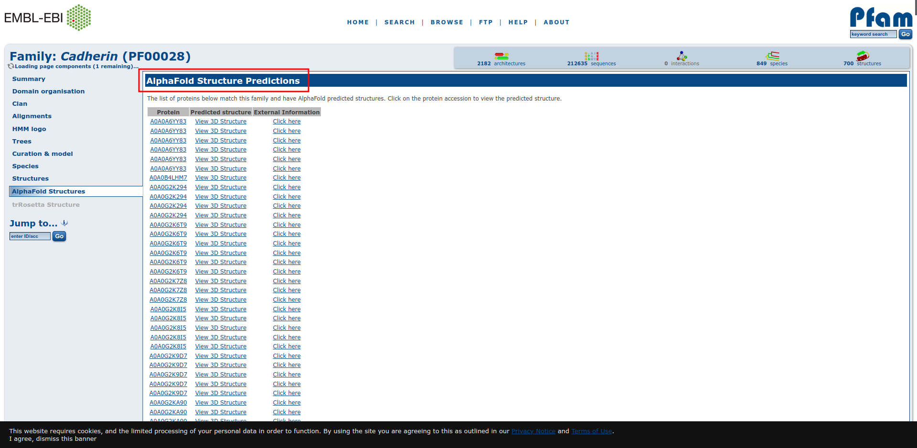
Fig15. Result page for Cadherin Domain showing AlphaFold structure predictions

Result:
The domain organisation, clan, alignment, HMM logo, trees, curation and model, species, structure and AlphaFold structure information related to Cadherin Domain was retrieved using Pfam database.

Conclusion:
Pfam database provides protein domain family information which includes sequence alignments, profile
Hidden Markov models which helps understand how much an amino acid is conserved. It also provides
functional annotations and literature references. All this information can be easily retrieved from Pdam
database by its users.

References:
- Maître, J. L., & Heisenberg, C. P. (2013). Three Functions of Cadherins in Cell Adhesion. Current Biology, 23(14), R626–R633. https://doi.org/10.1016/j.cub.2013.06.019
- Keyword search results. (n.d.). Retrieved from http://pfam.xfam.org/search/keyword?query=Cadherin
- Keyword search results. (n.d.). Retrieved from http://pfam.xfam.org/family/PF00028#tabview=tab1
- Keyword search results. (n.d.). Retrieved from http://pfam.xfam.org/family/PF00028#tabview=tab2
- Keyword search results. (n.d.). Retrieved from http://pfam.xfam.org/family/PF00028#tabview=tab3
- Keyword search results. (n.d.). Retrieved from http://pfam.xfam.org/family/PF00028#tabview=tab4
- Keyword search results. (n.d.). Retrieved from http://pfam.xfam.org/family/PF00028#tabview=tab5
- Keyword search results. (n.d.). Retrieved from http://pfam.xfam.org/family/PF00028#tabview=tab6
- Keyword search results. (n.d.). Retrieved from http://pfam.xfam.org/family/PF00028#tabview=tab7
- Keyword search results. (n.d.). Retrieved from http://pfam.xfam.org/family/PF00028#tabview=tab8
- Keyword search results. (n.d.). Retrieved from http://pfam.xfam.org/family/PF00028#tabview=tab9

Date: 12-10-21
WEBLEM 5c
BLOCK
(URL: https://www.ebi.ac.uk/interpro/)
Aim:
To study Cadherin domain information using InterPro database.
Introduction:
InterPro is an integrative database which was founded 10 years ago when the PROSITE, PRINTS, Pfam and ProDom databases formed a consortium to amalgamate the predictive signatures they individually produced into a single resource. Since then, six other member databases have also joined and their data has been integrated: SMART, TIGRFAMs, PIRSF, SUPERFAMILY PANTHERand Gene3D.
Cadherins (named for "calcium-dependent adhesion") are a type of cell adhesion molecule(CAM) that are important in the formation of adherens junctions to allow cells to adhere to each other .Cadherins are a class of type-1 transmembrane proteins, and they are dependent on calcium (Ca2+) ions to function, hence their name. Cell-cell adhesion is mediated by extracellular cadherin domains, whereas the Intracellular cytoplasmic tail associates with numerous adaptors and signaling proteins, collectively referred as the cadherin adhesome.
Methodology:
- Open Homepafe for InterPro database. (URL: https://www.ebi.ac.uk/interpro/)
- Search for query “Cadherin” Using search by sequence.
- Observe the resutls.
- Interpret the results.
Observation:
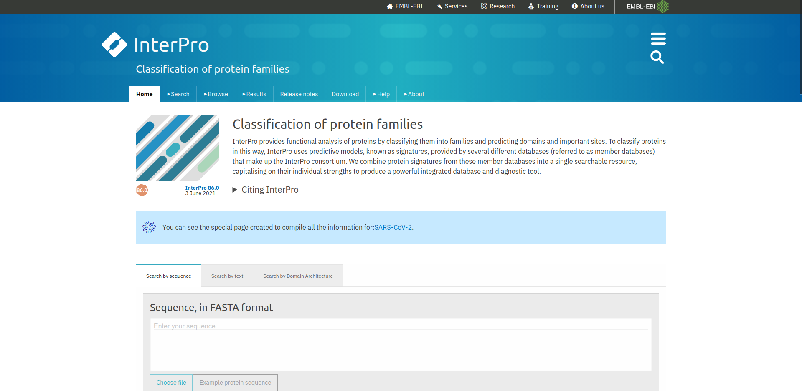
Fig1. Homepage for InterPro database.
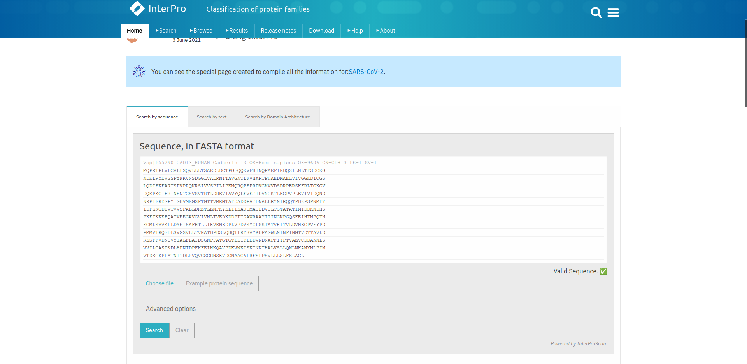
Fig2. Search page for query “Cadherin” using search by sequence

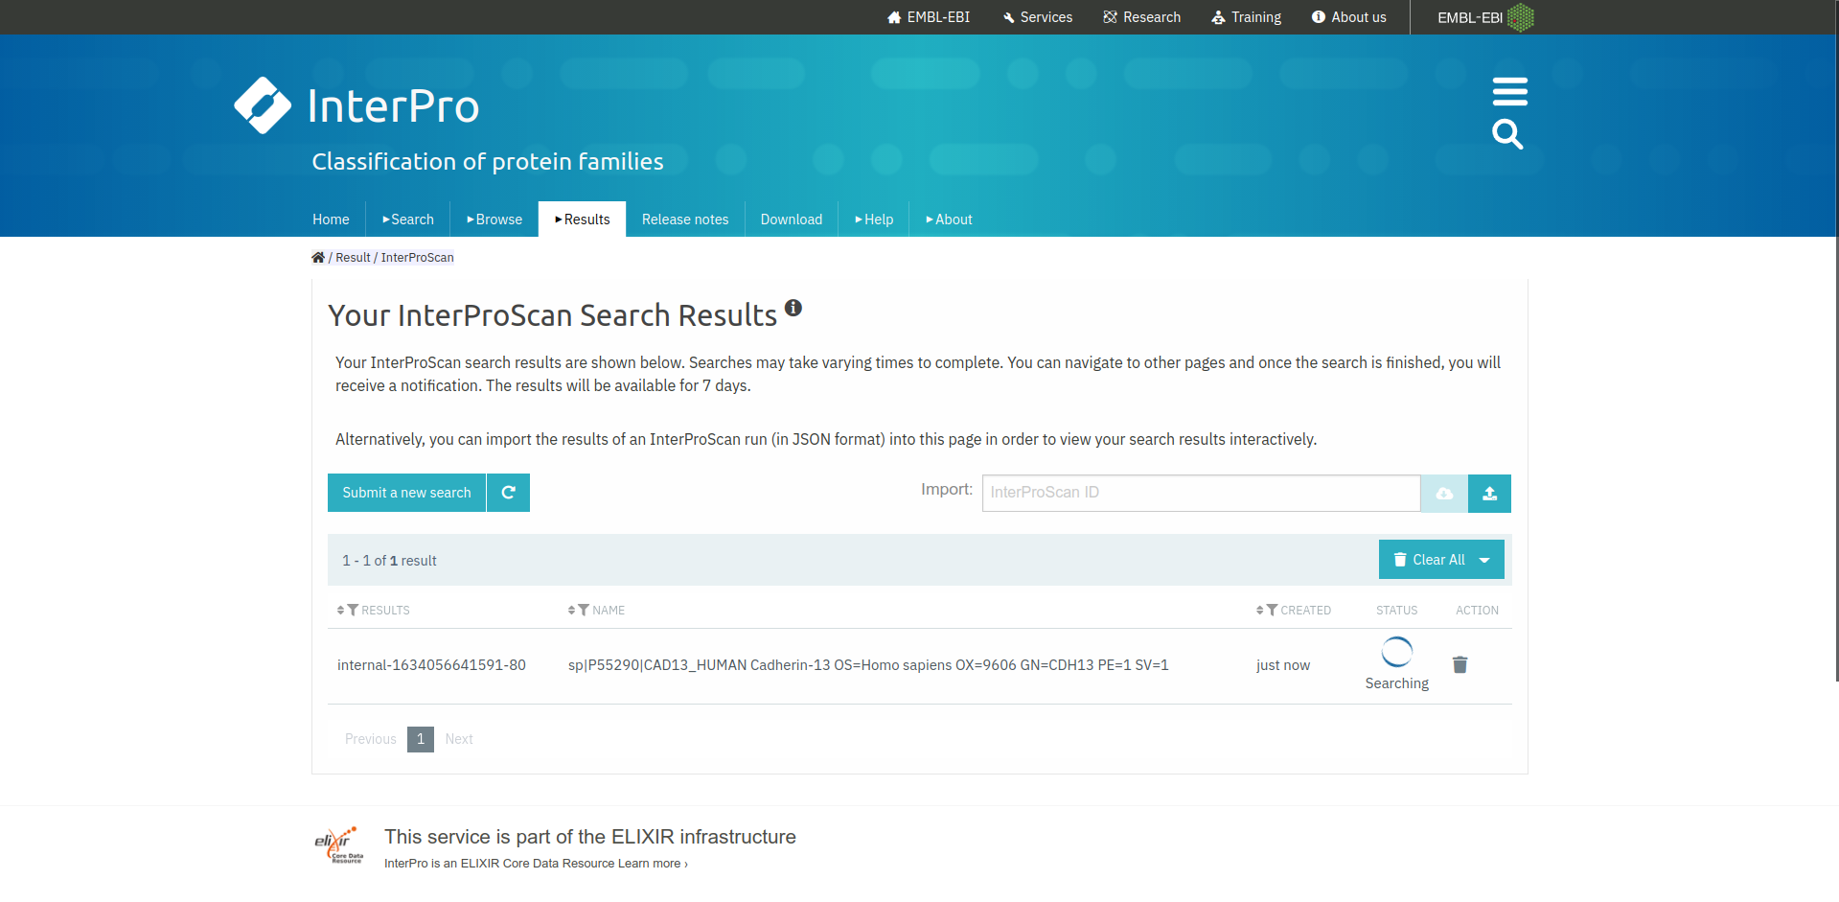
Fig3. Hit page for query “Cadherin” in InterPro database.

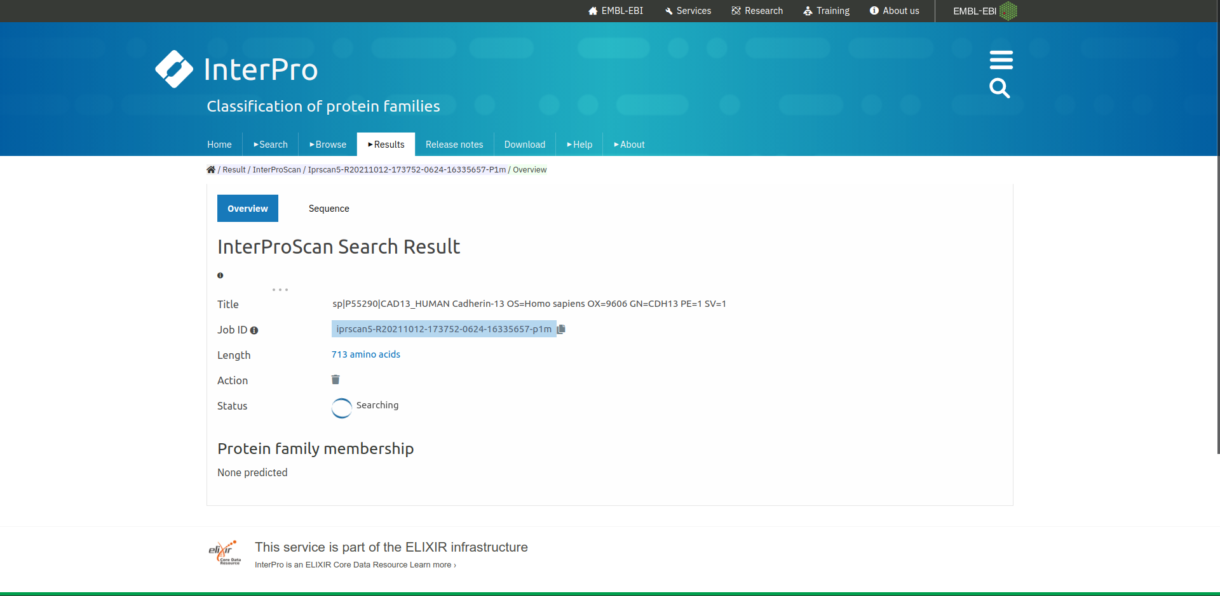
Fig4. Result page for query “Cadherin”

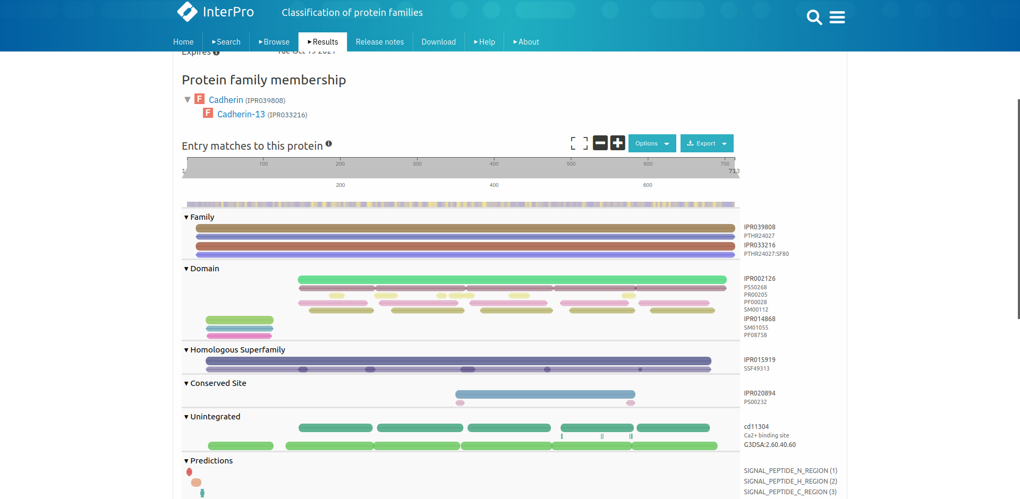
Fig5. Result page for query “Cadherin” showing its family information

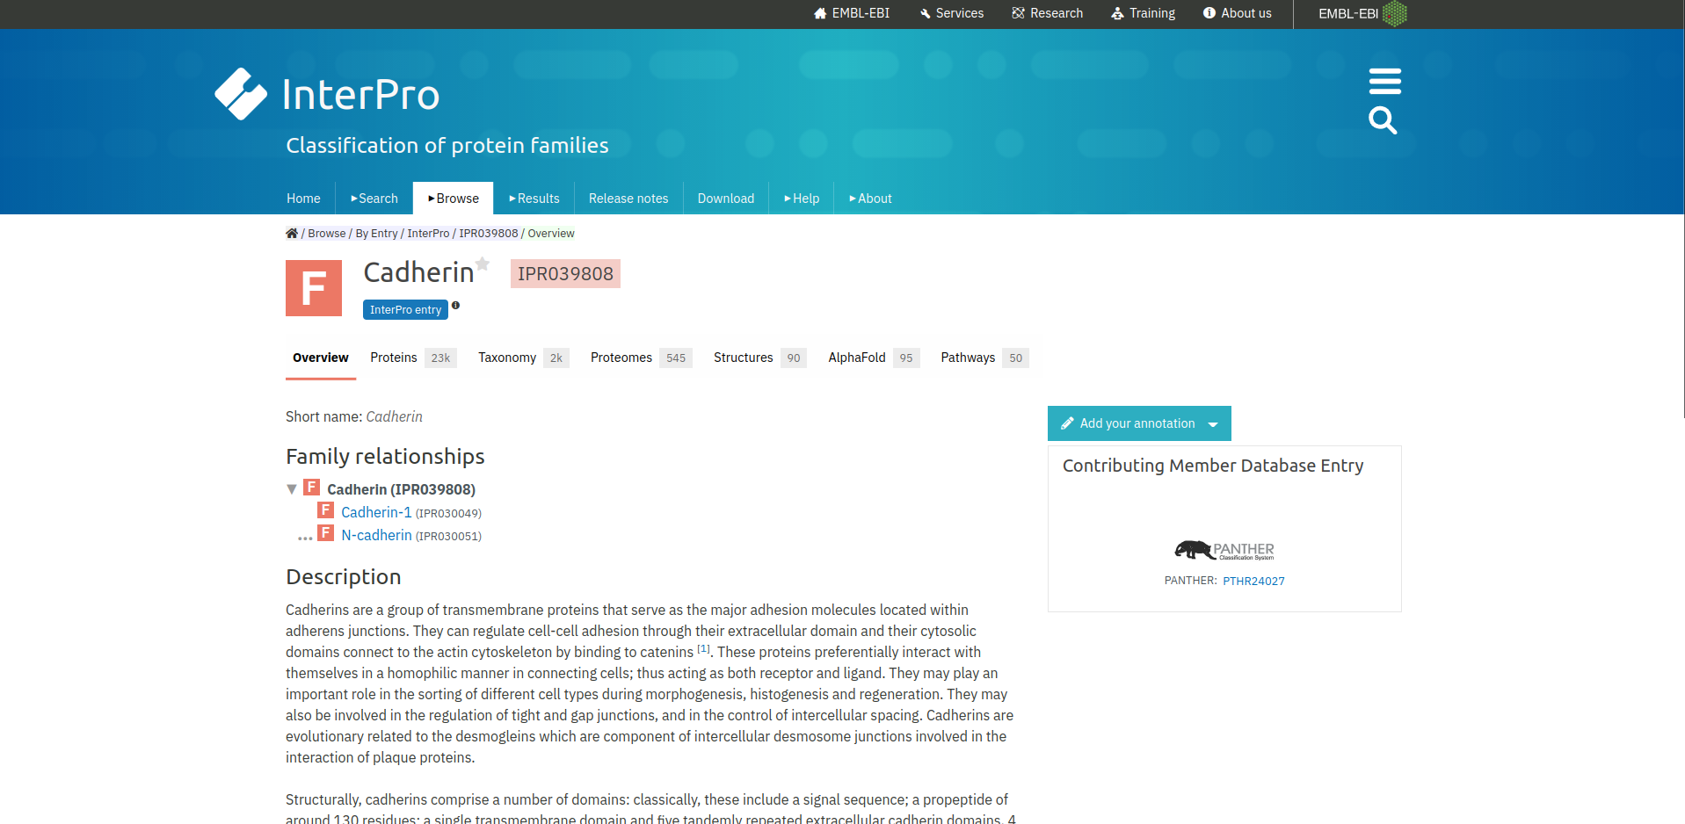
Fig5.1. Result page for Cadherin family.

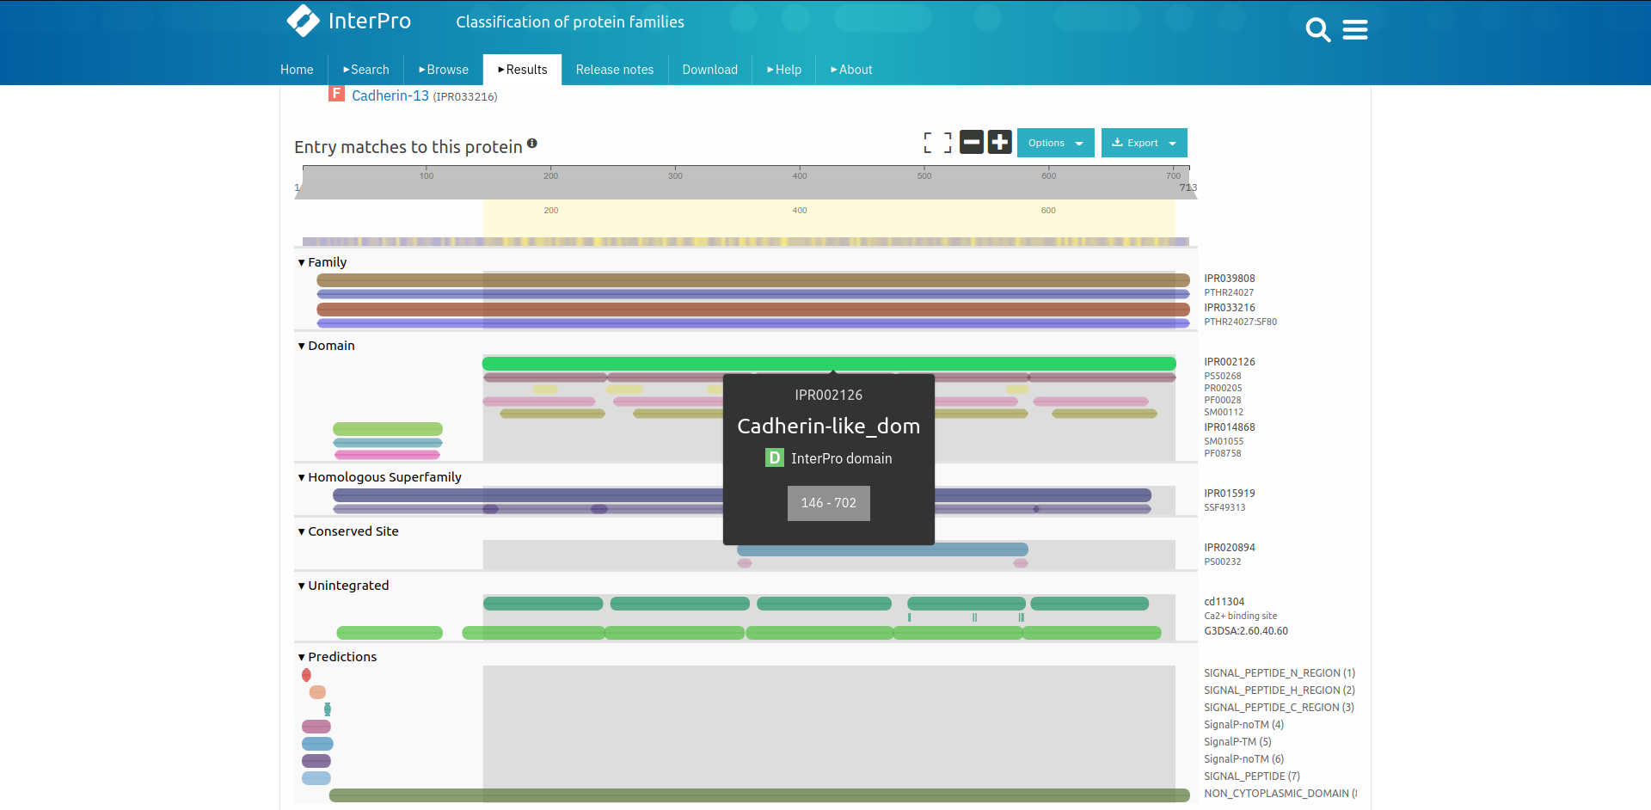
Fig6. Result page for query “Cadherin” showing its domain information

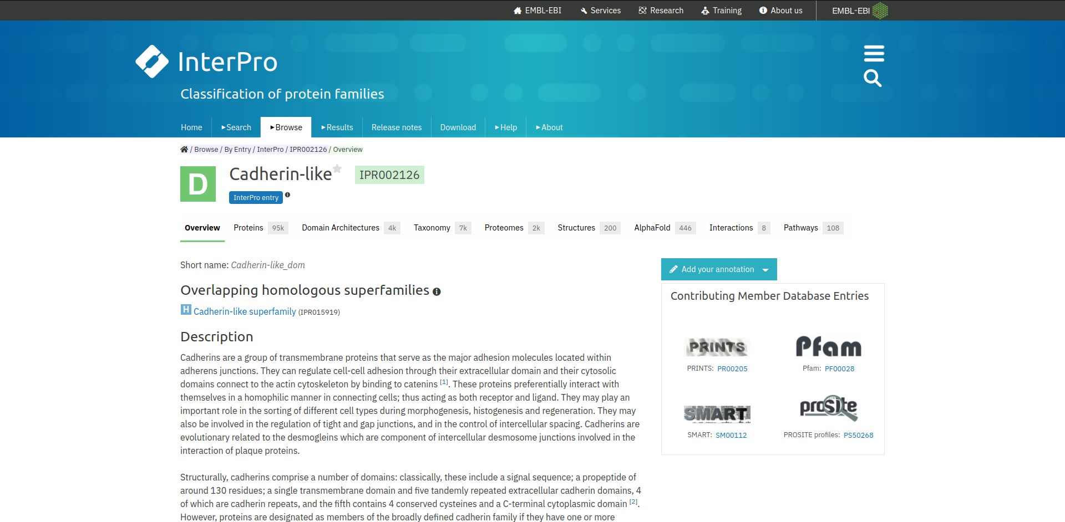
Fig6.1 Result page for Cadherin-like domain

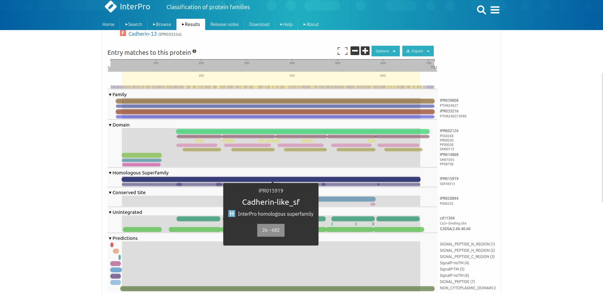
Fig7. Result page for query “Cadherin” Showing its homologous superfamily information

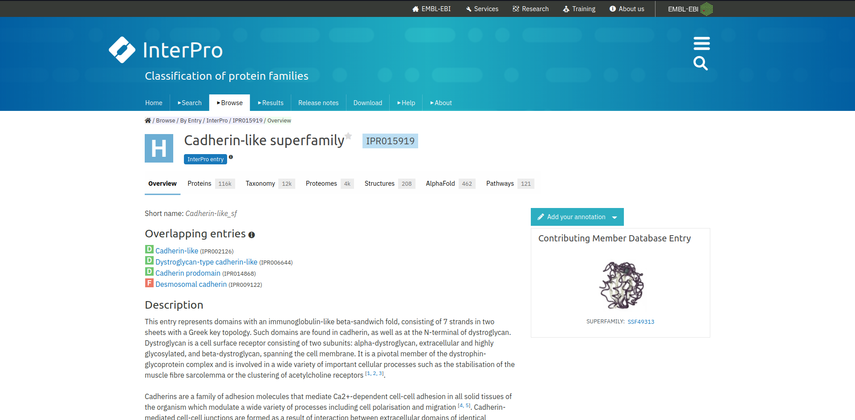
Fig7.1 Result page for Cadherin-Like superfamily

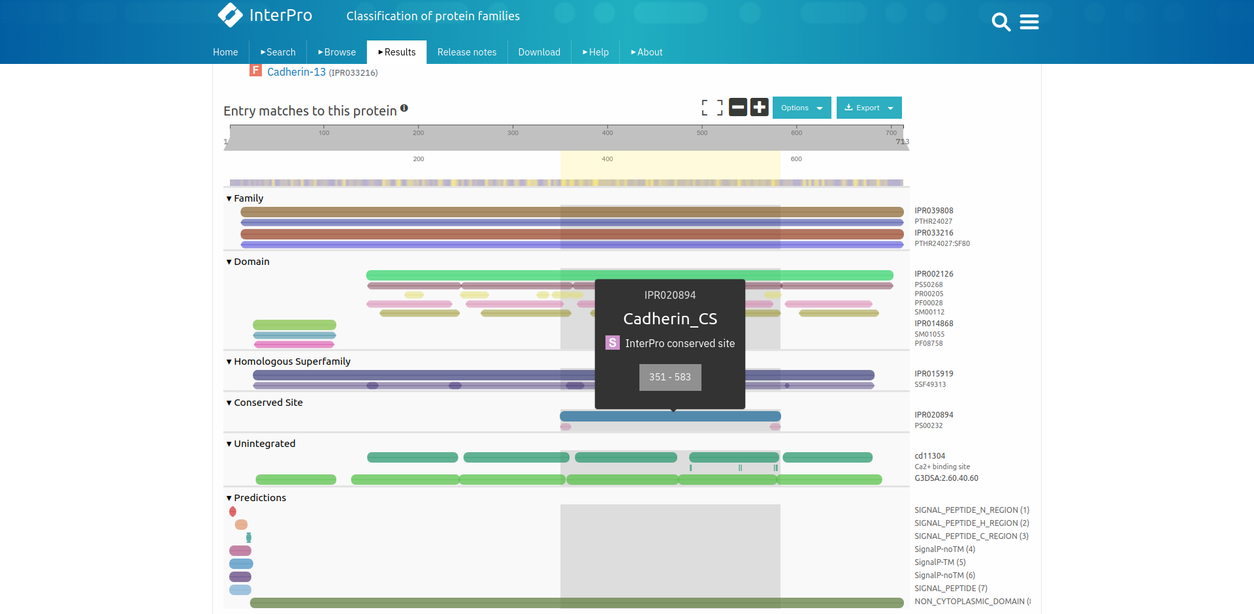
Fig8. Result page for query “Cadherin” Showing conserved site information

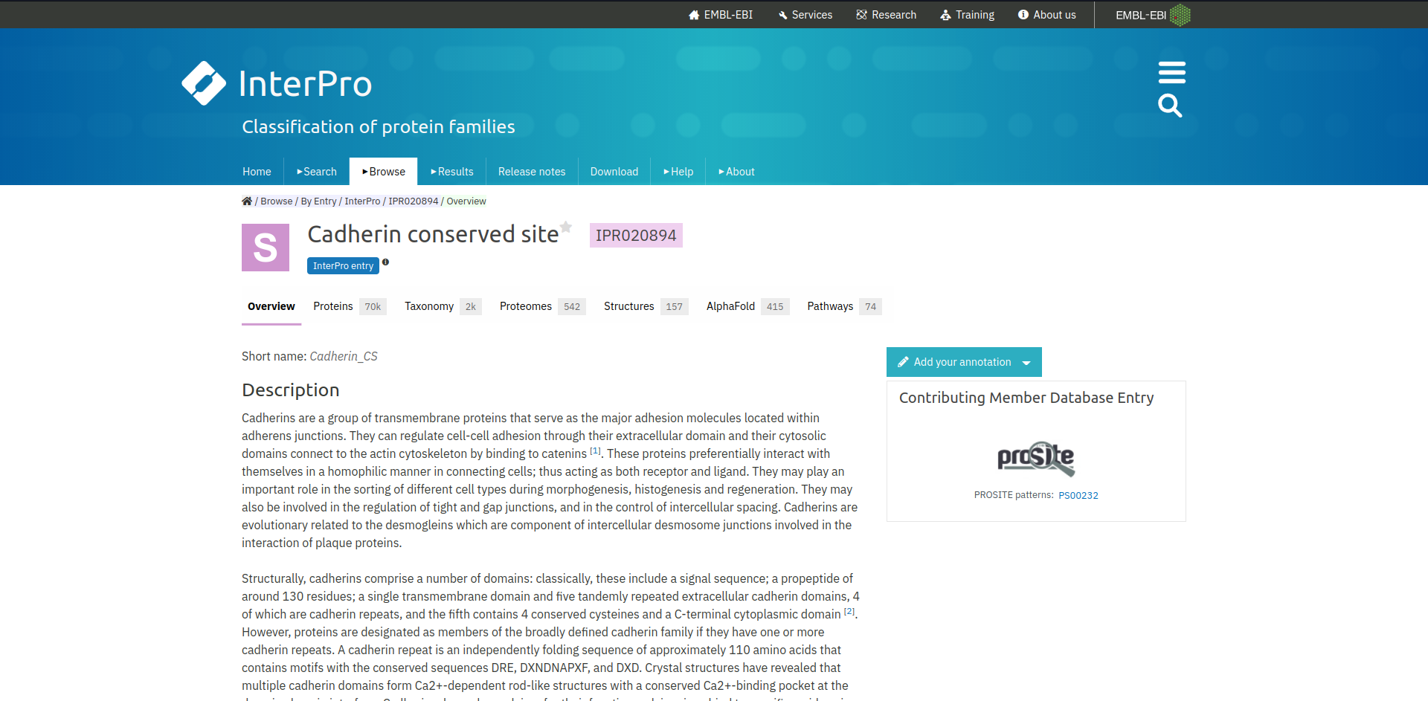
Fig8.1 Result page for Cadherin conserved site

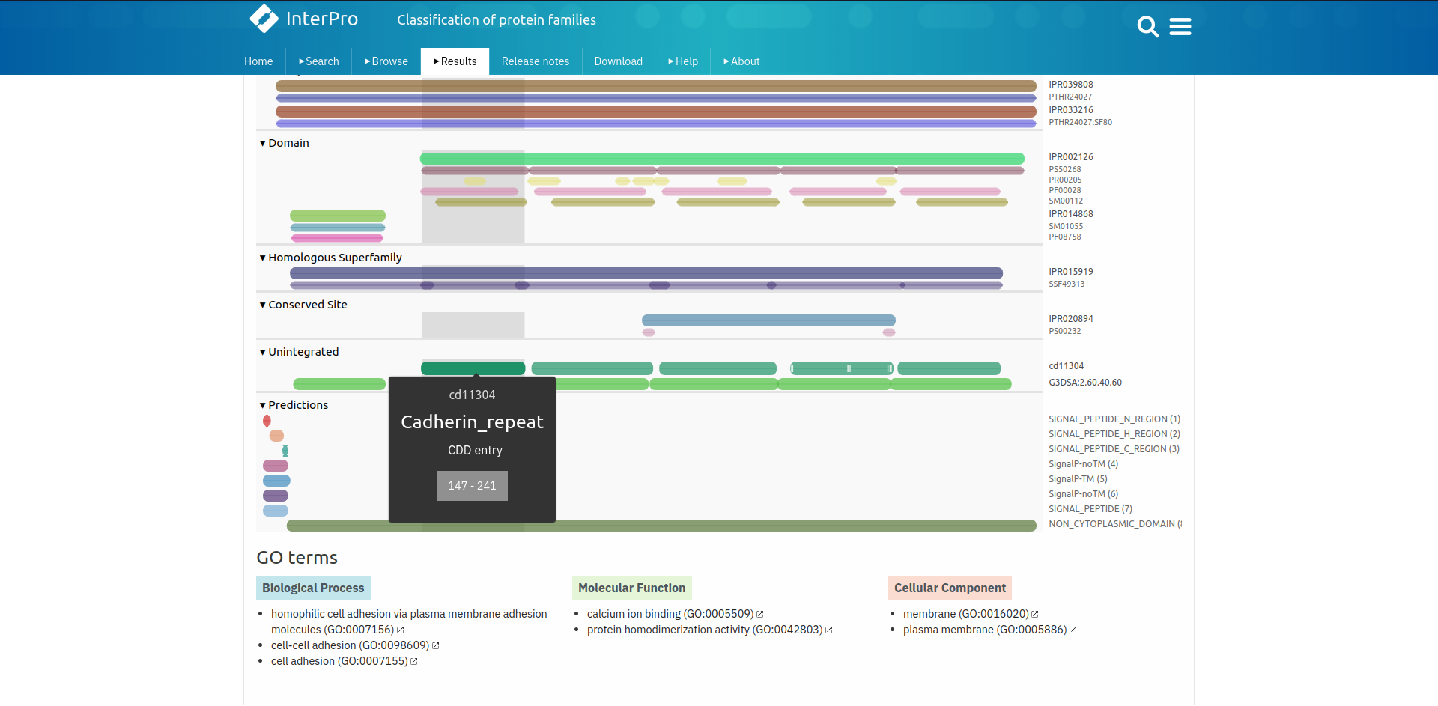
Fig9. Result page for query “Cadherin” showing Unintegrated information

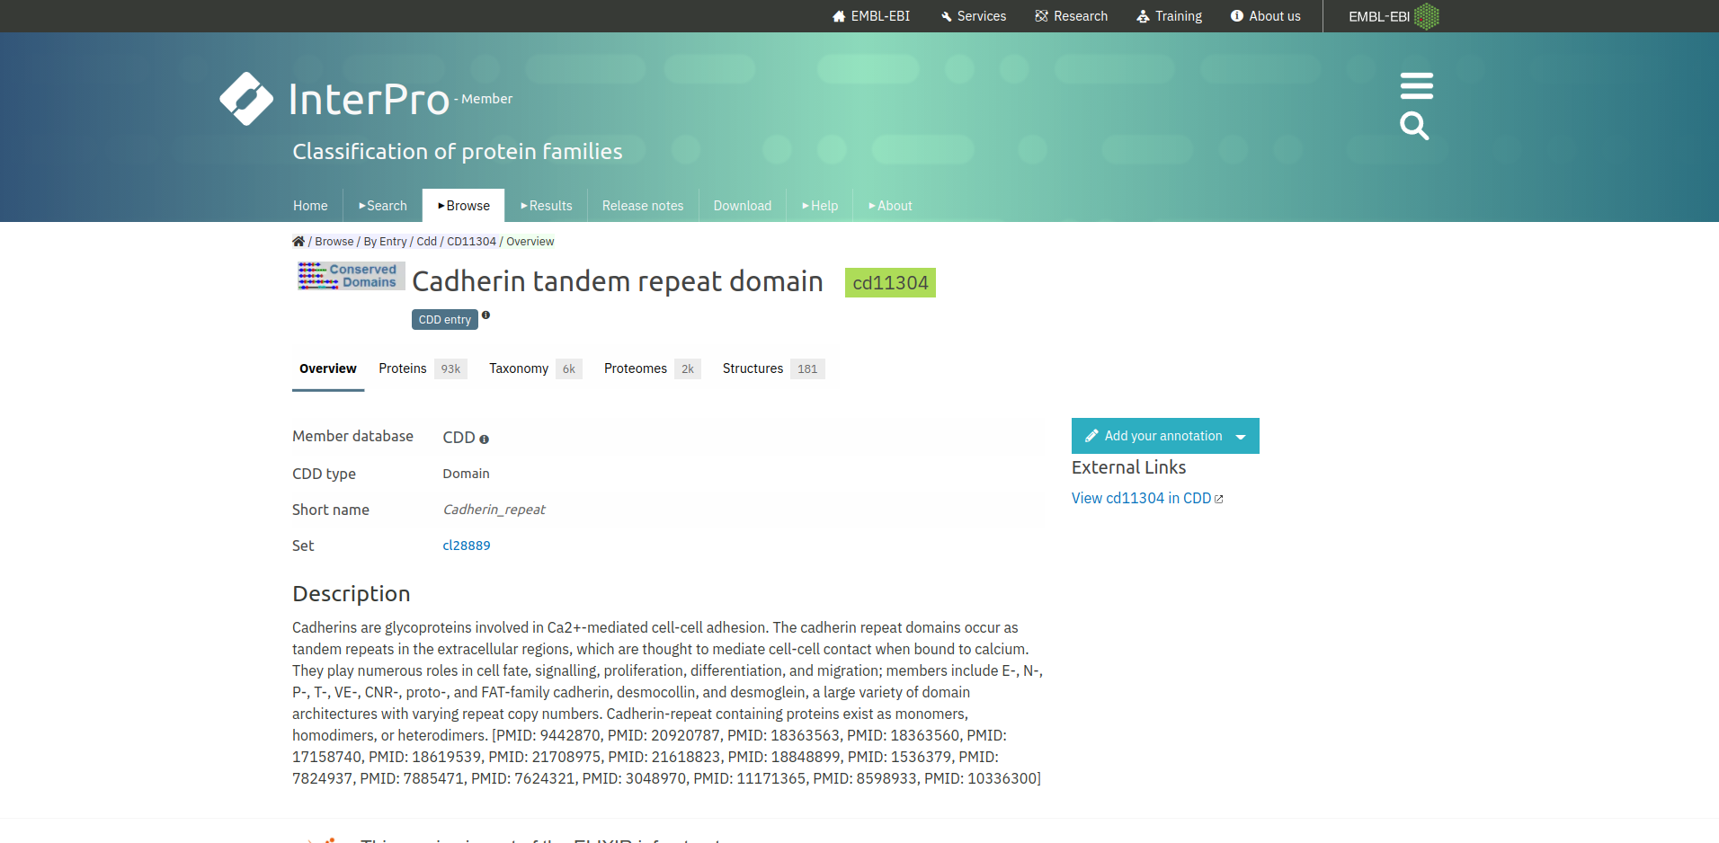
Fig9.1 Result page for Cadherin tandem repeat domain Unintegrated information

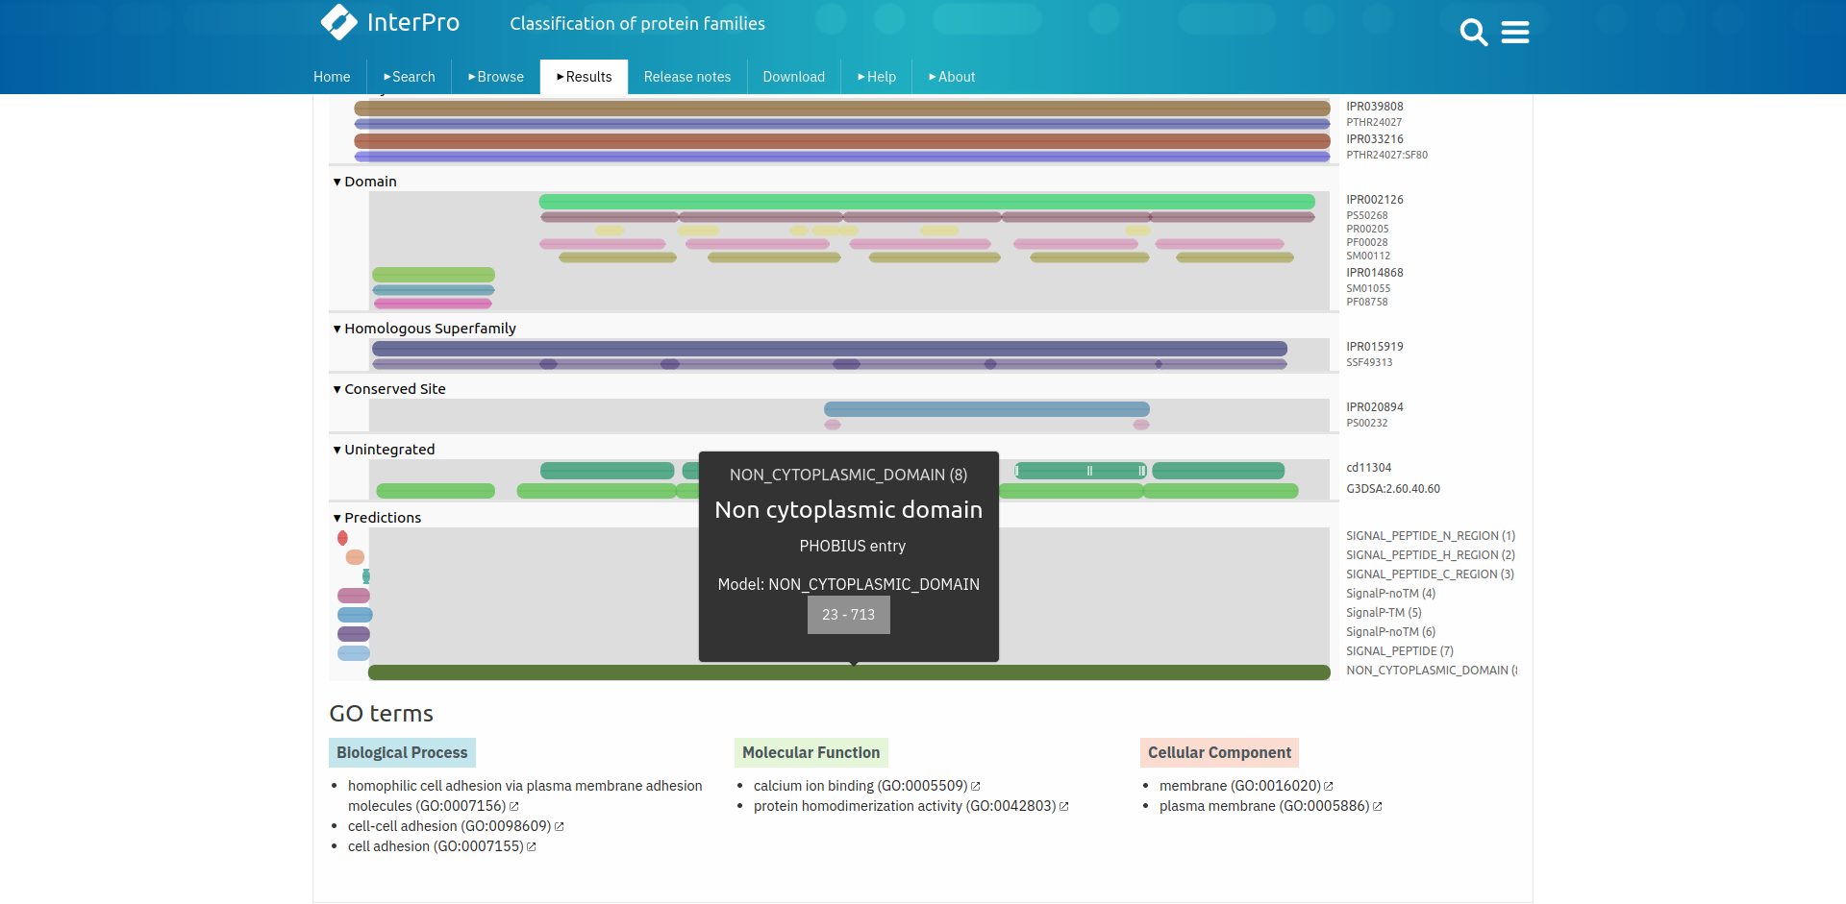
Fig10. Result page for query “Cadherin” Showing predications

Result:
The family, domains, conserved sites, unintegrated information and predictions for Cadherin protein was retrieved from InterPro database

Conclusion:
InterPro database provides its users functional analysis of protein which are classified using predictive models into families and predictive domains. It provides information of protein family, domains, conserved and active sites. This database is useful for cross referencing protein domain information with other databases.

References:
- Maître, J. L., & Heisenberg, C. P. (2013). Three Functions of Cadherins in Cell Adhesion. Current Biology, 23(14), R626–R633. https://doi.org/10.1016/j.cub.2013.06.019
- (n.d.). Retrieved from https://www.ebi.ac.uk/interpro/
- (n.d.). Retrieved from https://www.ebi.ac.uk/interpro/result/InterProScan/#table
- (n.d.). Retrieved from https://www.ebi.ac.uk/interpro/result/InterProScan/iprscan5-R20211012-173752-0624-16335657-p1m/
- (n.d.). Retrieved from https://www.ebi.ac.uk/interpro/entry/InterPro/IPR039808/
- (n.d.). Retrieved from https://www.ebi.ac.uk/interpro/entry/InterPro/IPR002126/
- (n.d.). Retrieved from https://www.ebi.ac.uk/interpro/entry/InterPro/IPR015919/
- (n.d.). Retrieved from https://www.ebi.ac.uk/interpro/entry/InterPro/IPR020894/
- (n.d.). Retrieved from https://www.ebi.ac.uk/interpro/entry/cdd/CD11304/

